EFD UFT Walkthrough

Navigate to the website https://www.efdnasaa.org to begin.
This document shows filers how to create a UFT Offering and submit a UFT submission/payment.
Contents:
Screen: Home Page 2
Screen: Login Screen 3
Screen: Accept Terms and Conditions 4
Screen: Filers Home 5
Screen: Filers Home UFT 5
Screen: Create New UFT Offering or Other Filing 6
Screen: Manage UFT Offering Page 7
Screen: Select Submission Type 7
Screen: Jurisdiction Selection 8
Screen: File List 9
Screen: UFT File Upload 9
Screen: File List - Post File Upload 11
Screen: UFT Description and State Fees 12
Screen: Submission Confirmation 13
Screen: Manage UFT Drafts – Add to Cart 14
Screen: UFT Payment Cart Details 14
Screen: UFT Payment Cart Confirmation 15
Screen: UFT ACH Payment Collection 16
Questions: 17

Screen: Home Page
This is the home page for the Electronic Filing Depository, which is available at https://www.efdnasaa.org.
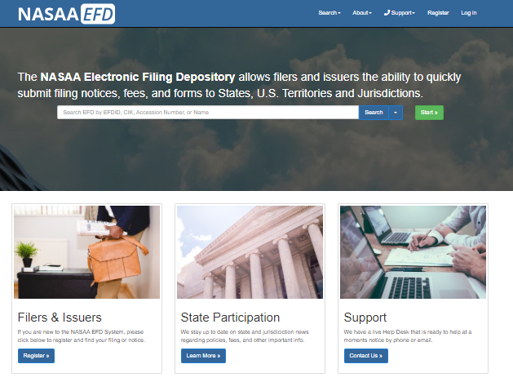
Filers must complete the registration process in order to create a new account (see the Filer Registration document).
If a Filer already has an account with EFD, then the Filer clicks Log In at the top of the screen.

Screen: Login Screen
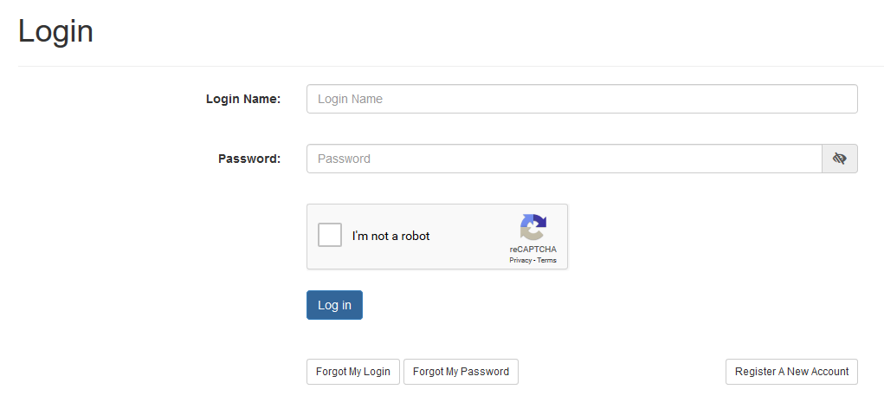
- The Filer must enter their Login Name and Password.
- The Filer must select the ‘I’m not a robot’ option, and pass any reCAPTCHA authentication.
- The Login Name IS NOT case sensitive.
- The Password IS case sensitive.

*Use the option buttons at the bottom of this screen to retrieve lost Login Names or reset your Password.
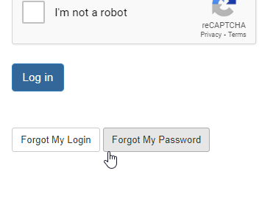

Screen: Accept Terms and Conditions
Filers must click the Accept the Terms and Conditions button upon logging into the EFD website.
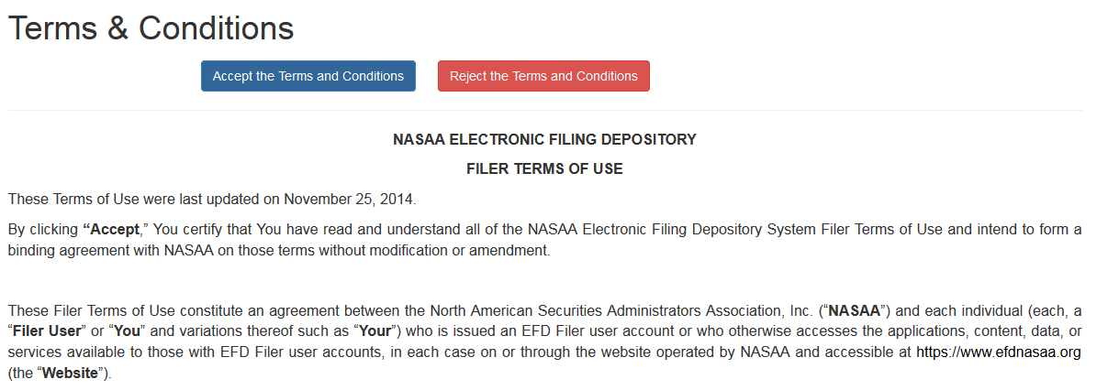

Filers will not be allowed to proceed until the Terms and Conditions on this screen are accepted.

Screen: Filers Home
After accepting the Terms and Conditions, Filers are logged in and the Filer’s Login Name will appear at the top of the screen. To get back to this page at any time you only have to click on your name/username in the top right and click on “Filer Home”.
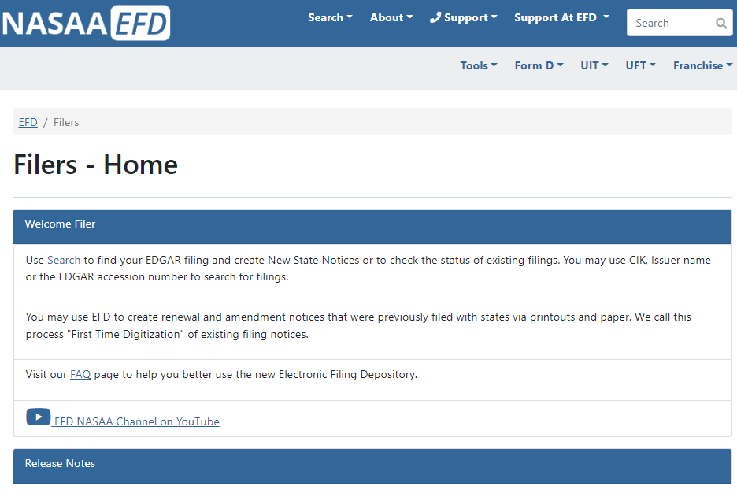

Screen: Filers Home UFT
The next step to creating a UFT Offering and filing for the states
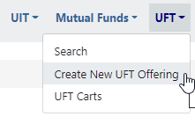

Screen: Create New UFT Offering or Other Filing
The filer/issuer will fill out the offering name and offering type. You will be required to provide a description of the offering. Select what group the UFT offering is being associated to.
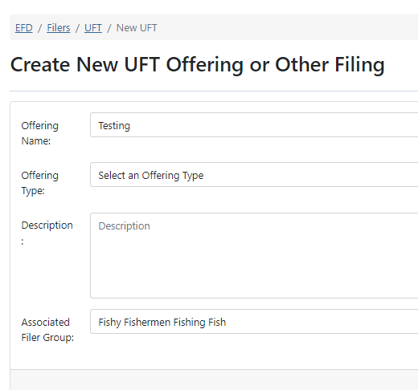

Screen: Manage UFT Offering Page
Drafts - Add a filing submission or submit an adhok payment to a state.
The Shared document - Please note that files uploaded as Shared Documents are included with every submission and to all jurisdictions. This behavior continues until the document is removed from the shared documents list. For documents to individual states please upload files through the Drafts box.
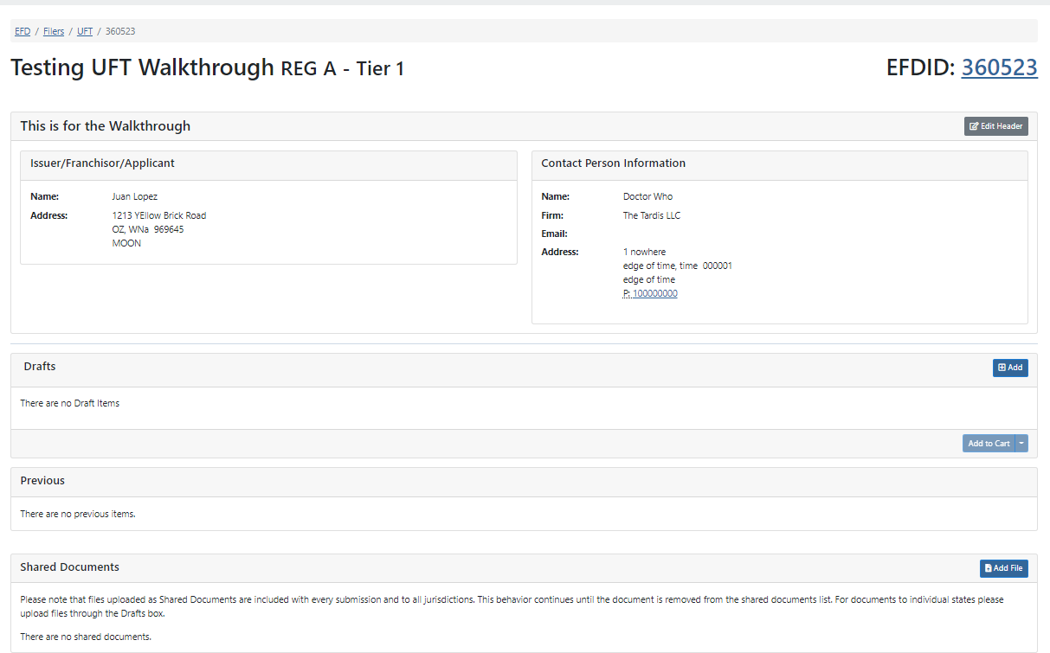
To make a submission you will click on the “[+] ADD” button in the DRAFTS section. This will direct you to select what type of submission you’re making.
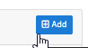

Screen: Select Submission Type

Select a submission type. Keep in mind that states can not accept an ad-hoc payment until there is a filing submission on file through EFD first.
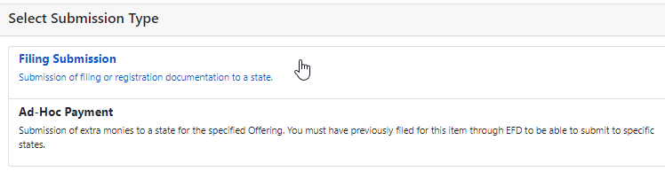

Screen: Jurisdiction Selection
Select what states you will be filing your submission with. Some states are crossed out because they do not accept the offering type you selected. For Example - In the image below we selected a REG A – Tier 2 filing and Connecticut doesn’t allow for a Reg A – Tier 2 filing through EFD.
When you are done selecting your states you will click “NEXT”.
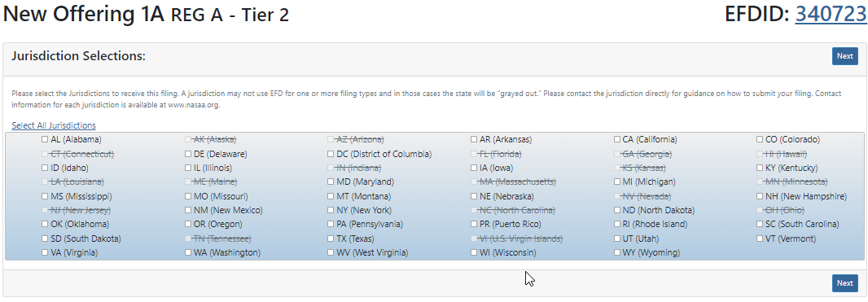

Screen: File List
The file list page shows you all the files that have been added and what states are associated to said files. To add a new file, you will click on “Add File”. You must have at least one filer per state.
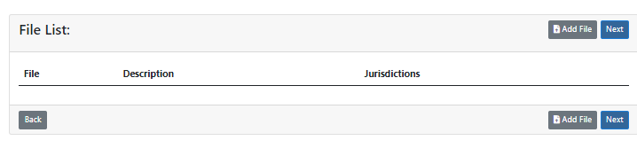

Screen: UFT File Upload
The file upload screen requires you to do things in a particular order. You will first state the file description. Then click on the state to the left. You can select multiple states by holding down the CTRL key on your key board and clicking the other states. Now you have the ability to browse for your file. Click on “Browse” or drag and drop your file unto this box.
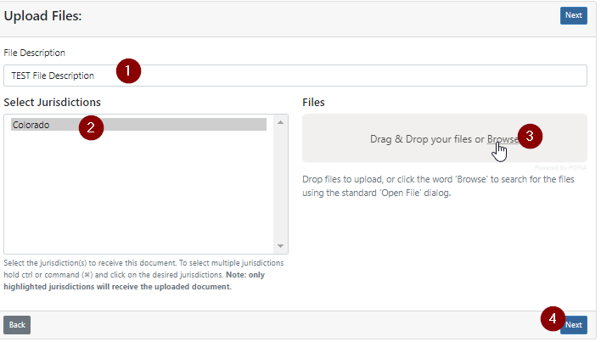
The file will then begin to upload. Wait for the “Upload Completed” green bar to appear.
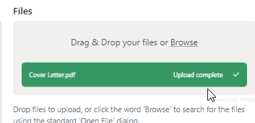
Click on “NEXT”
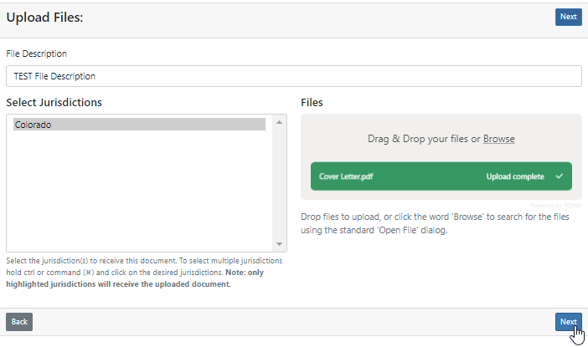

Screen: File List - Post File Upload
You can redownload the document you uploaded to check the integrity of the document or to make sure it is the correct document. You can also delete the said document.
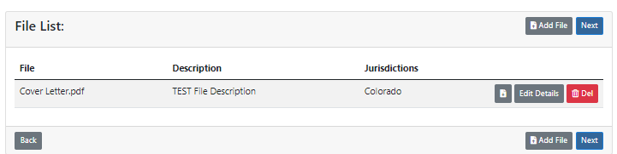
You have the ability to click on “Edit Details” to add more states to the file submission you uploaded. Be sure to click “Save Value” to commit the change.
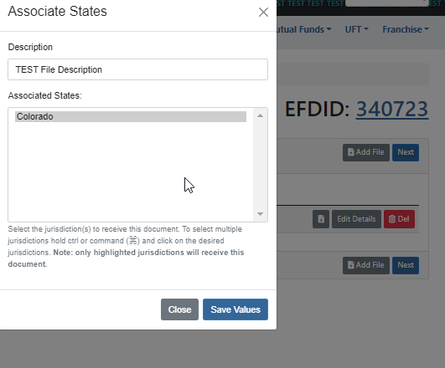
When you are ready be sure to click on “NEXT”
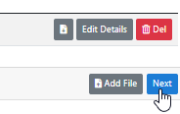

Screen: UFT Description and State Fees
This page wants a short but brief description of the submission (What is it for). Then you have the Option to provide a File Number (not required). You must provide the Fee Type (Put NA if there is no fee). You must provide a fee amount (put 0 if no fee).
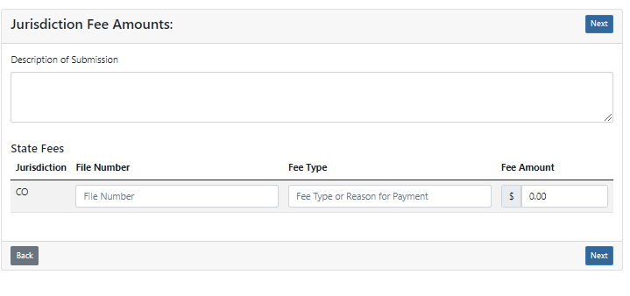
You will now double check everything and click on “NEXT”
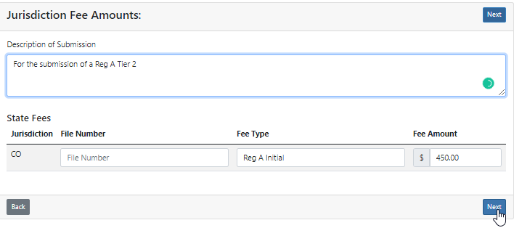

Screen: Submission Confirmation
The Filer/Issuer will now be given the ability to confirm all the information provided thus far. Clicking “NEXT” will ready the draft to be paid for. If there is no fee then the filing will be submitted to the states.
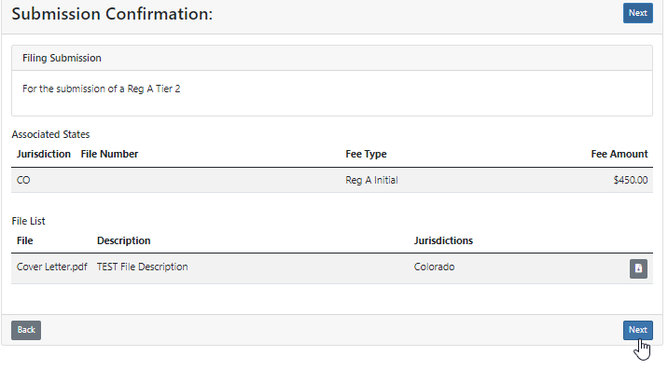

Screen: Manage UFT Drafts – Add to Cart
The filer/issuer will need to click on the check mark to the left of each filing submission needing to be filed.
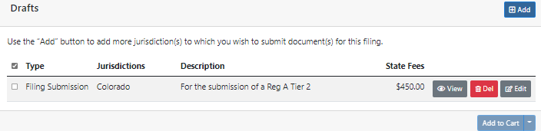
Then the filer/issuer will click on “Add to Cart” or select the drop down next to Add to Cart to specify what cart it goes into.
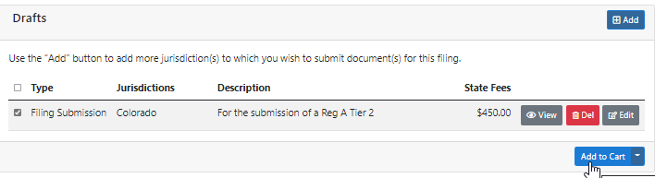
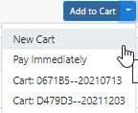

Screen: UFT Payment Cart Details
The Payment details and contact information are required to associate the filing to a filer/issuer group and individual. Friendly Name is already created by the system but can be changed by the filer. You will need to make sure that you selected which payment group the filing is being associated to (default is My Private group). The Funds request memo is required for most law firms. It’s an in house identifier for clients or payment tracking. Think of it like a memo field on a check. Receipts Emails an email collection that will send all email(s) provided a copy of this receipt (the account holders primary email already gets a copy of said receipt). The Contact Information is who is paying for the filing. Click “NEXT” when you’re ready to proceed.
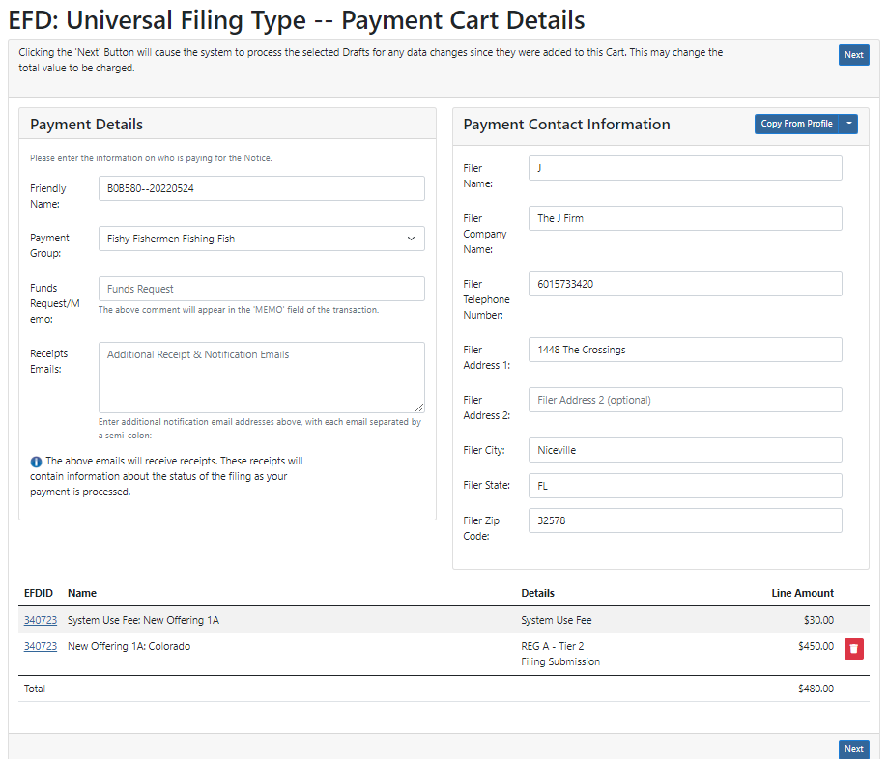

Screen: UFT Payment Cart Confirmation
This screen will give you the ability to confirm the details you provided thus far. If everything looks correct you can proceed by clicking on “NEXT”. If you need to make a correction you can click on “BACK”.
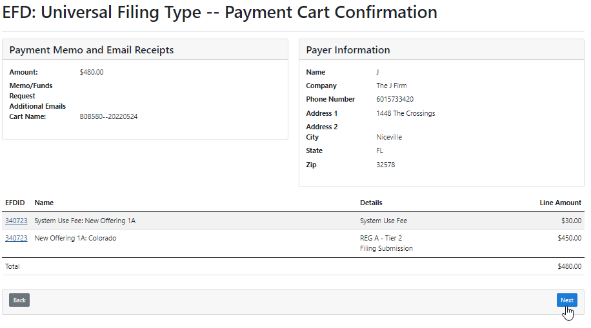

Screen: UFT ACH Payment Collection
The ACH Payment screen allows you to securely enter your ACH payment details and submit both the filing and fees to the state. The purpose of the ACH Payment Collection page allows the filer to make payments by ACH. That is a U.S. Account and Routing number that allow for debiting on the checking account. Not all financial institutions allow ACH Payments. You will want to verify with your bank and accounting department to ensure you’re able to make an ACH payment. When you’re ready click the check box for “I agree with the below terms” and click “Make Payment”.
If you are using a business account you can proceed to click “Make Payment”. However, if you are using a consumer account you will need to obtain an Authorization code from EFD Support 601-453-1979.

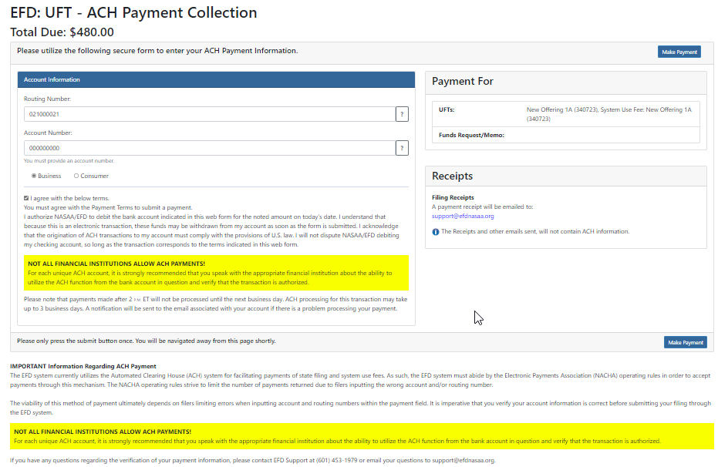
After clicking “Make Payment” The payment is then scheduled and a receipt is sent to the primary email address listed on the account of the filer who made the payment. The receipt is proof of being filed unless there is a deficiency in payment or regulatory action is made against the filing.
You will be redirected to a Thank You page.
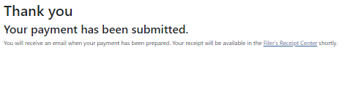
Questions:
NASAA EFD Support
601-453-1979
support@efdnasaa.org
Support Hours
9 AM EST – 6 PM EST
Excluding National Holidays

