EFD FORM NF UIT Walkthrough
Navigate to the website https://www.efdnasaa.org to begin.

Purpose:
This document will show how a Filer can create UIT Filings within the EFD system.

Background:
This document assumes that you have already registered with the EFD system. For help with EFD registration, please see additional help documentation for Registration.
Contents:
Purpose: 1
Background: 1
Screen: Home Page 2
Screen: Login Screen 3
Screen: Accept Terms and Conditions 4
Screen: Home Screen Logged In 5
Screen: Search Screen 7
Screen: Search Results 8
Screen: View Filing 8
Screen: Select States 9
Screen: Configure Trust Information 11
Screen: Configure Trust Issuer 11
Screen: Configure NF Overview 12
Screen: Configure NF Type 13
Screen: Configure NF Offering Amount 15
Screen: Configure NF Sales Report 16
Screen: Configure NF Increase Offering Amount 16
Screen: Configure NF Other 17
Screen: Configure NF Amendment 18
Screen: Configure NF Contact Information 18
Screen: Configure NF Issuer 20
Screen: Confirm NF 20
Screen: Make Payment 22
Questions: 28

Screen: Home Page
This is the home page for the Electronic Filing Depository, which is available at https://www.efdnasaa.org.
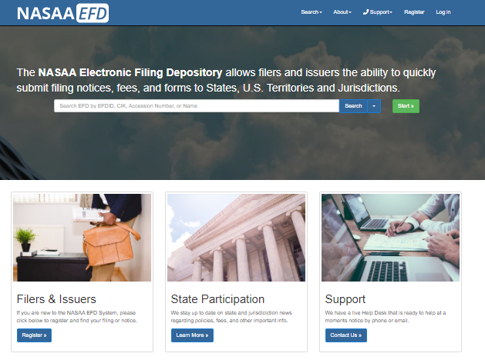
Filers must complete the registration process in order to create a new account.
If a Filer already has an account with EFD, then the Filer clicks Log In at the top of the screen.

Screen: Login Screen
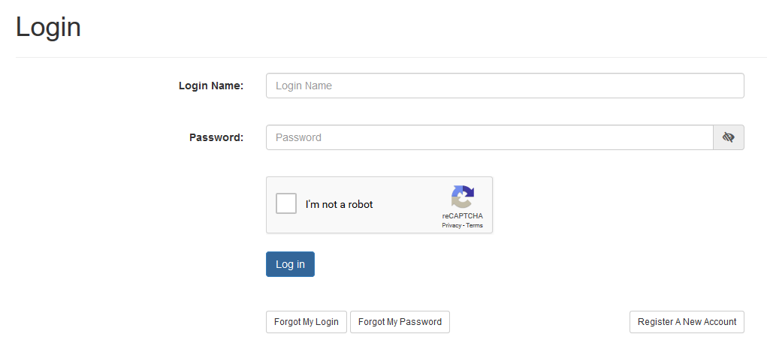

- The Filer must enter their Login Name and Password.
- The Filer must select the ‘I’m not a robot’ option, and pass any reCAPTCHA checks when presented.
- The Login Name IS NOT case sensitive.
- The Password IS case sensitive.

Use the option buttons at the bottom of this form to retrieve lost Login Names or Passwords.

Screen: Accept Terms and Conditions
Filers must click the Accept the Terms and Conditions button upon logging into the EFD website.
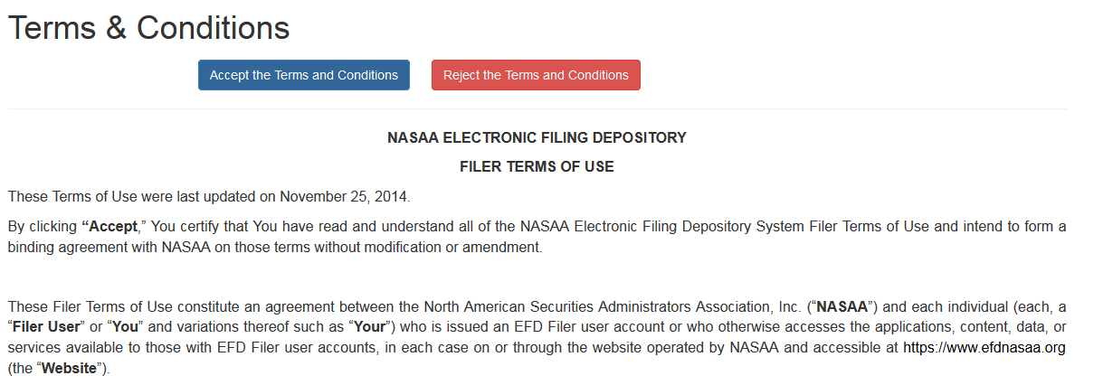

Filers will not be allowed to proceed until the Terms and Conditions on this screen are accepted.

Screen: Home Screen Logged In
After accepting the Terms and Conditions, Filers are logged in and the Filer’s Login Name will appear at the top of the screen.
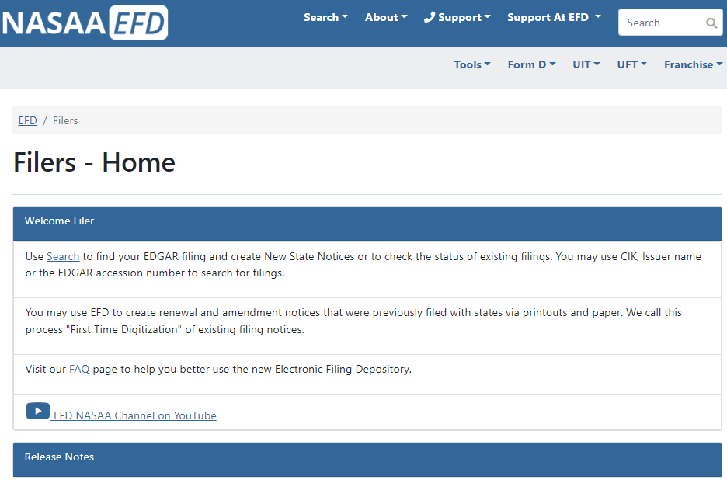
Filers may now begin the UIT notice creation process.
Click Search and select Form NF - UIT Search.
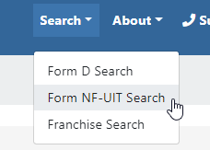

Screen: Search Screen
The Form NF-UIT search screen allows filers to search for Trusts pulled from the SEC EDGAR.
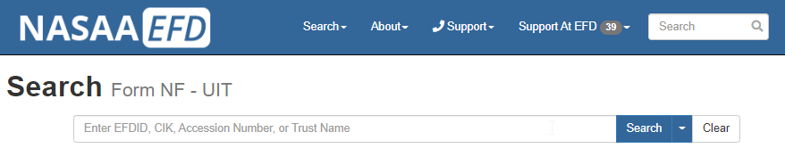
The FORM NF - UIT Search utility is used to search for the Form UIT Filing. Filers may use a variety of search criteria in the search input box including:
- CIK (Central Index Key)
- Default
- Accession Number
- EFDID
- Trust Name
- SEC File Number
The search results are limited to show only the first 100 results. If more than 100 results are found, the total number of matching results is provided above the results list and can be accessed by navigating to the next page of results.

Screen: Search Results
By clicking Search, Filers are provided with their search results. Click the EFD ID link to view the data retrieved from EDGAR.
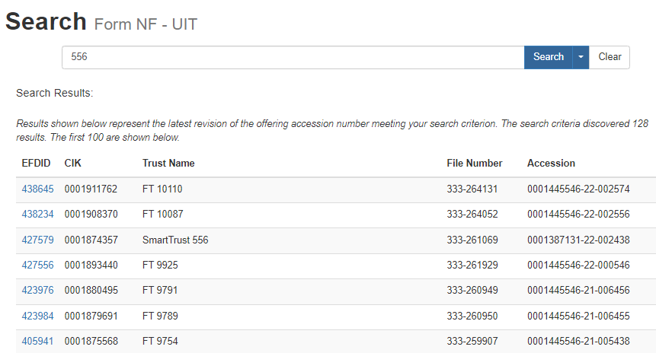

Screen: View Filing
Clicking the EFDID brings the Filer to the View Unit Investment Trust screen or View UIT for short. The View UIT screen displays information that was downloaded from EDGAR by EFD. EFD has provided references to the files that were provided at SEC’S EDGAR System.
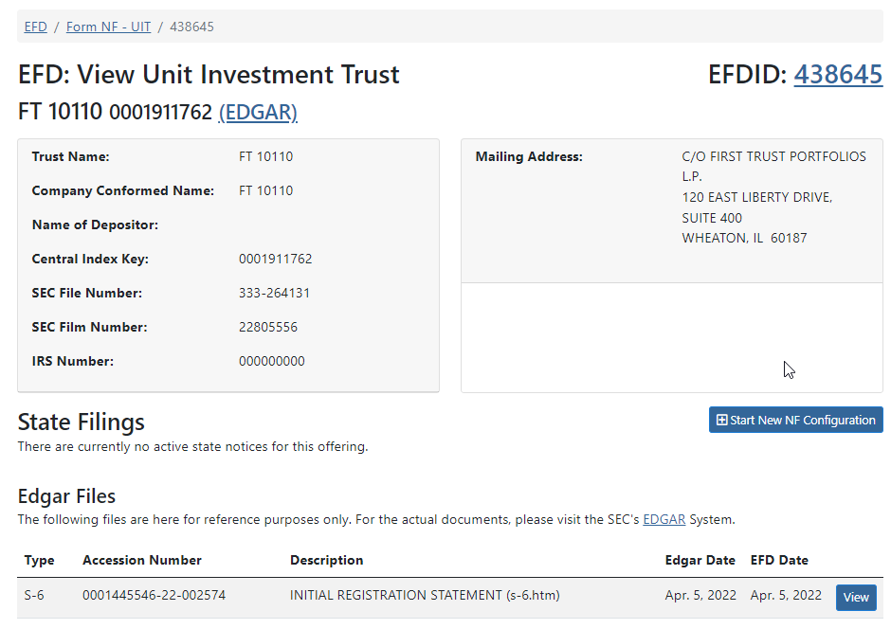
Once the Filer identifies the correct Trust, click the Start New NF Configuration button.
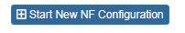

Screen: Select States

Clicking the Start New NF Configuration button directs the Filer to “Select States screen”. The Filer must select a state. If there is a selection already it could be because the states represent the selections made in recipient information in EDGAR. If a state is disabled it’s because another user retains control of the trust.
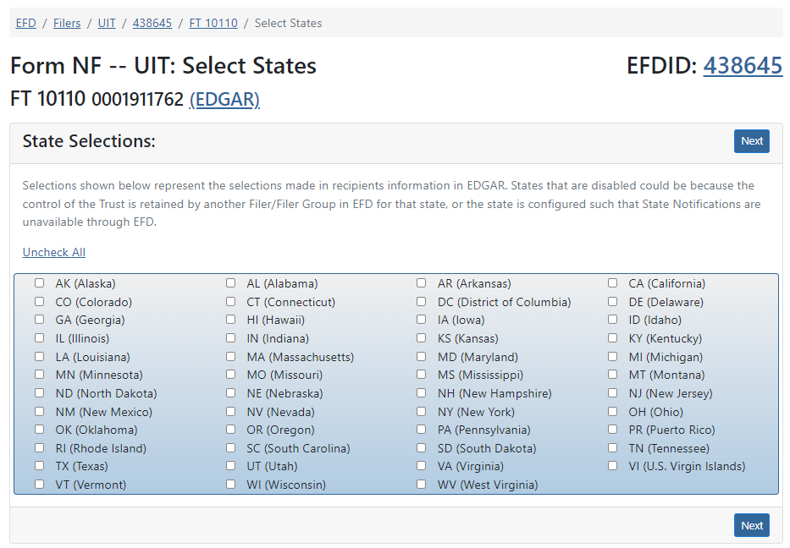
Click Next to proceed to the next step.

Screen: Configure Trust Information
Next, the Filer will indicate the Trust information, Contact Information, Additional Information (Broker Dealer, CIK, BD CRD#, and more), and Notice Period Dates.
Contact Information has a “Copy from Profile” button and drop down. You can load your group information here. This is similar to FORMD Filer Information.
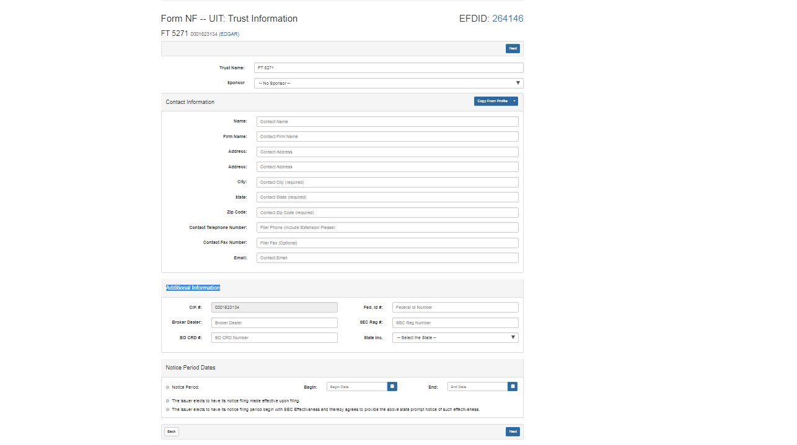

Click Next to proceed to the next step.

Screen: Configure Trust Issuer
Filers must supply the Issuer Information. Filer can click on the “Copy From S6” to load information from the S6. If this is incorrect the filer will have to manually input the Issuer Information.
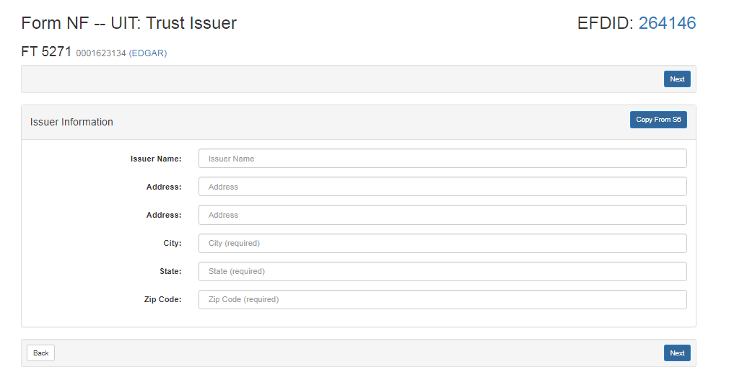
Click Next to proceed to the next step.

Screen: Configure NF Overview
The Overview page allows you to see your current UIT Configuration, drafts, and paid filings. Series/ Portfolio states will have a “[+] Add Series” next to it. Trust level states will have a “[+] Configure” next to it. To start a UIT filing click on “[+] Add Series” and/or “[+] Configure” button(s).
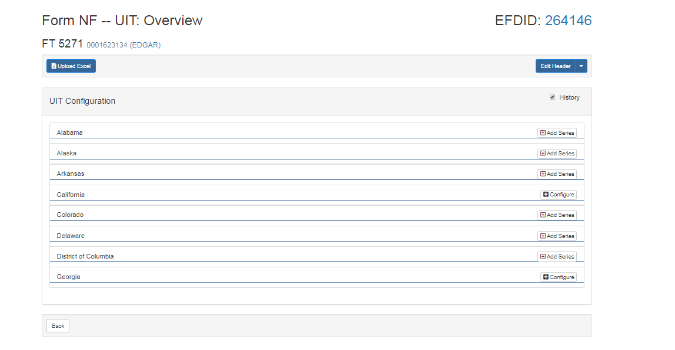

Screen: Configure NF Type
The Configure NF Type page will collect information based on state requirements and series level. If you are a Series/ Portfolio Level state you will provide a Series Name. We give you the filer the ability to provide your State File Number if you know this. Further you can provide a Securities Description and Fiscal year end of issuer. Select your Notice type to proceed.

Types of Notice Types (Circles) – You shall select at least one of the following:
- Initial
- Amendment
- Renewal
- Terminate
- Withdrawal
Specialized Notice Types (Squares) – You can select only one of the following:
- Exemption
- Sales Report
- Increase Dollar Amount
- Other

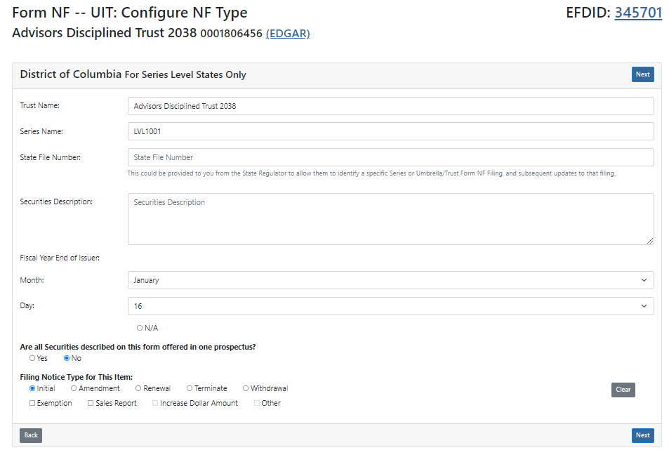
Click Next to continue.

Screen: Configure NF Offering Amount
The Filer Configure NF Offering Amount screen collects the Offering amount information.
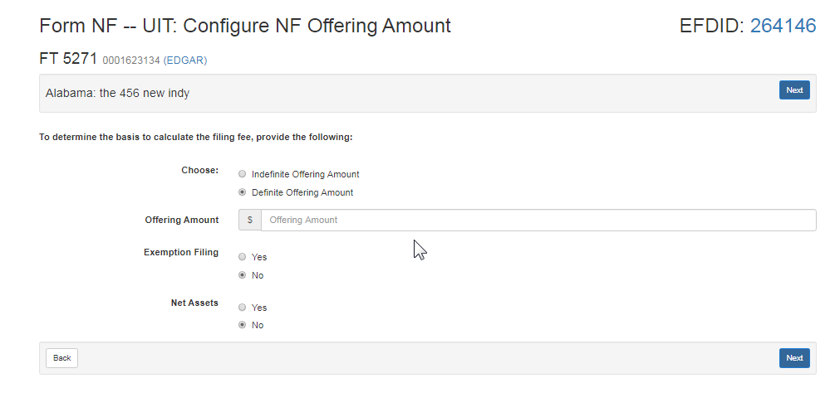
Click Next to continue.

Screen: Configure NF Sales Report

If the filer selected “ Sales Report” as a special notice type they will have to complete a Sales Report

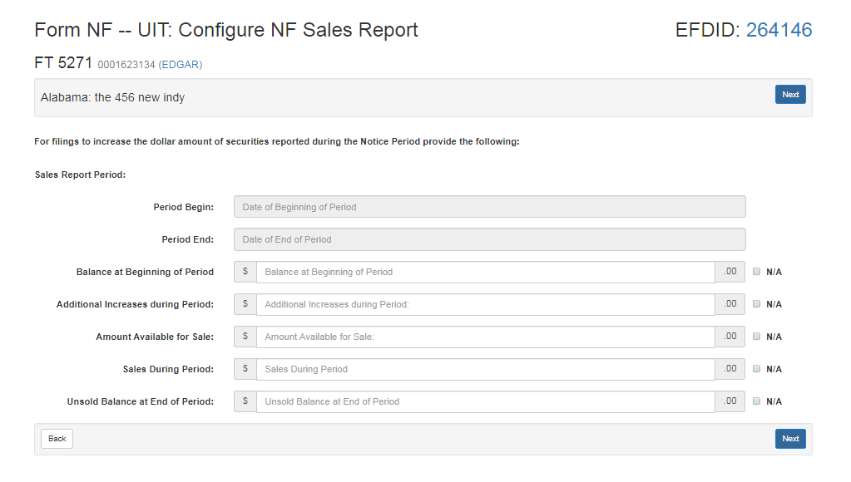
Click Next to continue.

Screen: Configure NF Increase Offering Amount
If you selected “Increase Offering Amount” as a special notice type you will have to fill out a increase of dollar amount of securities report.

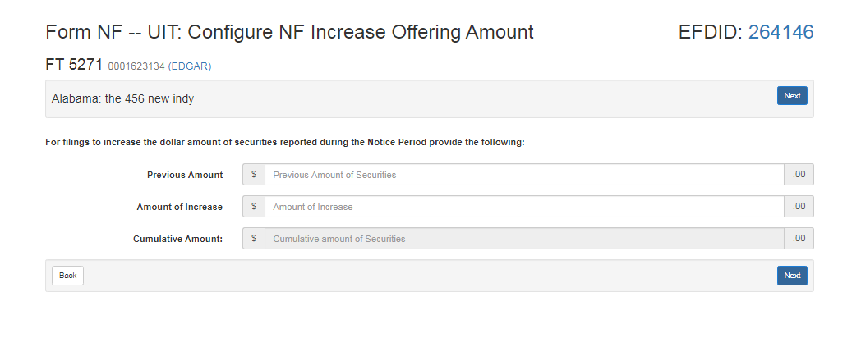

Click Next to continue.

Screen: Configure NF Other
If you select “Other” as a special notice type you will have the ability to notify the regulator of Other Notification Types. Keep in mind that this may generate post-filing charges requested by the state.
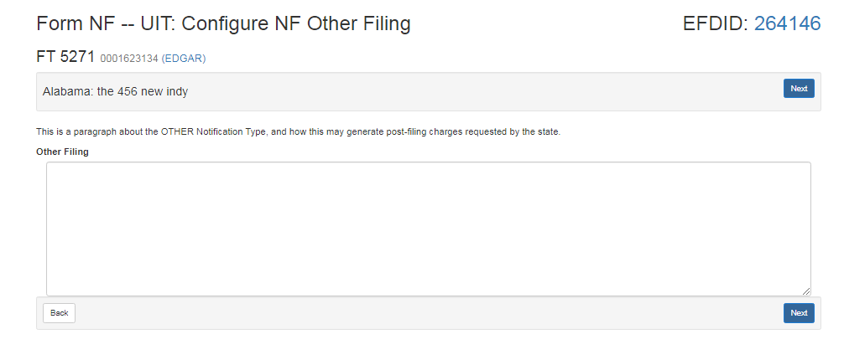
Click Next to continue.

Screen: Configure NF Amendment
This screens purpose is to determine if there are any “Specialty” type Amendments such as a Name Change.
Types of “Specialty” Amendments:
- Name Change
- Address Change
- Contact Change
- Other

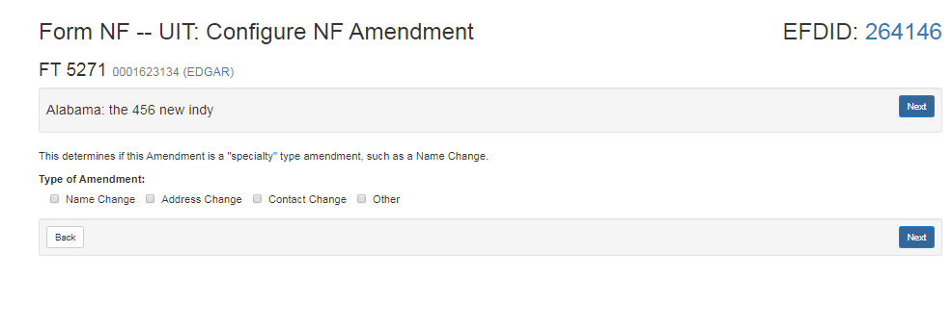
Click Next to continue.

Screen: Configure NF Contact Information
The following screen shows the filer the contact information entered during the configuration process. Review the information on this page before proceeding to the next page.
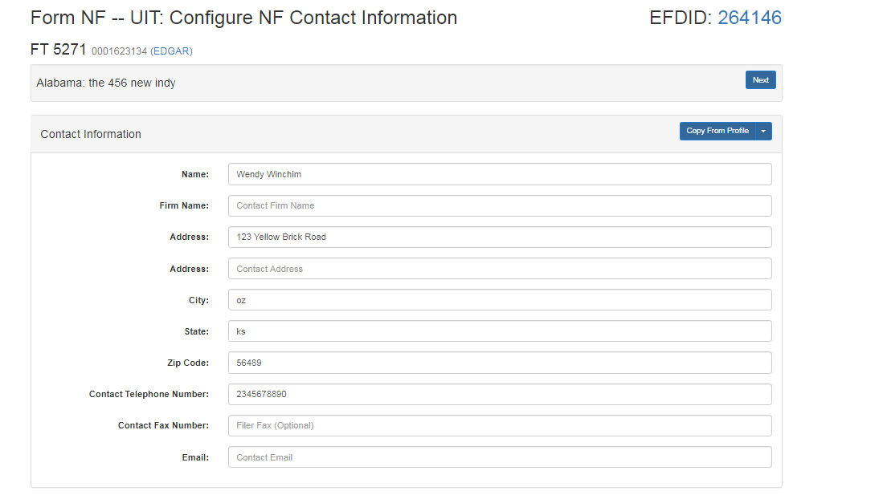
Click Next to continue.

Screen: Configure NF Issuer
The following screen shows the filer the Issuer information entered during the configuration process. Review the information on this page before proceeding to the next page. If nothing is available on the page you can click “Copy From S6” to load the issuer info from the S6 or manually input the information.

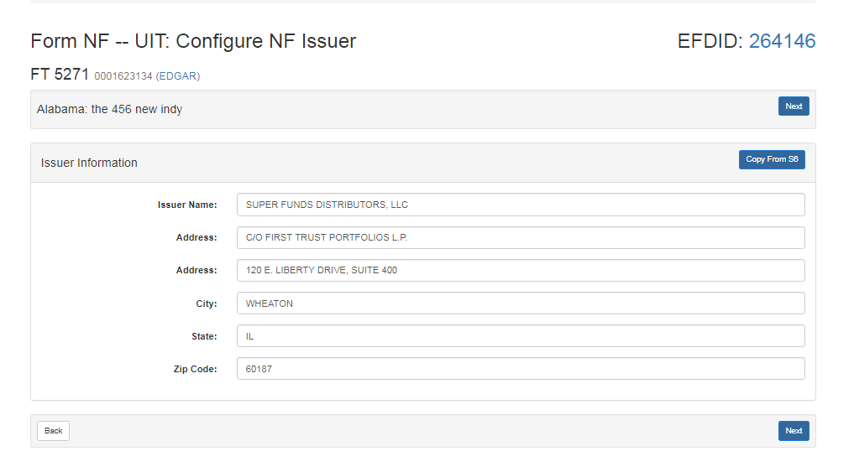
Click Next to continue.

Screen: Confirm NF
The following screen shows the filer what they have inputted during the filing process. The filer has the ability to click the three dots next to each section to go back and make a change if necessary. If everything looks correct the filer can click the check box for Signature and provide a Signature and Title.
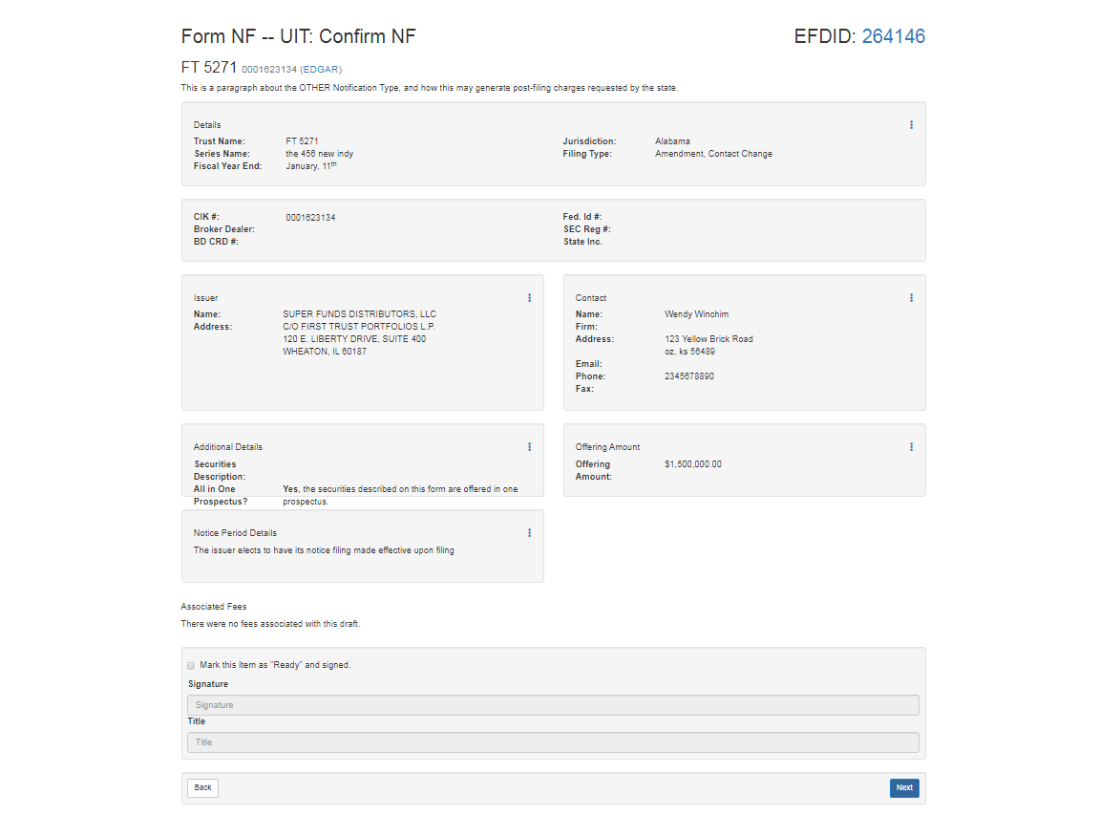
Click Next to continue.

Screen: Make Payment
The following steps are how you make a payment for a manually entered UIT filing. If there is a green check mark next to series /trust filing in question then it’s ready for payment.
- When you’re ready to pay click on the “Pay” button at the top of the screen.
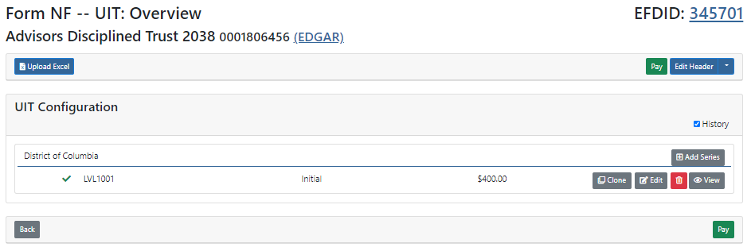
- Accept and Agree to the U2 consent to service of process * New York requires the filing of a paper version specific Form U-2 with the Department of State. Please see the EFD System FAQ section for more information https://www.efdnasaa.org/FAQ/answer?faq=30
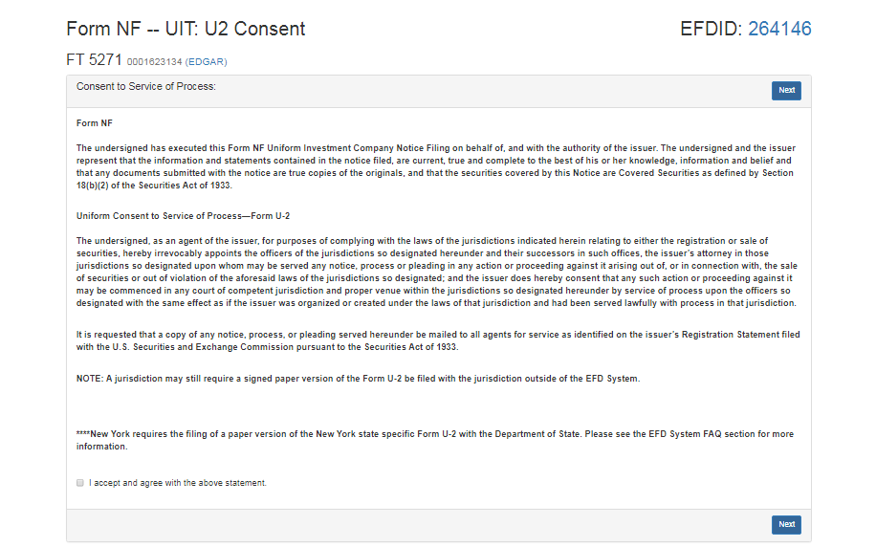
- Select all States and filings you wish to add to your payment cart. Then look in the bottom right at your Add to Cart button and click on the down arrow. You have the ability to click New Cart (creates new payment cart), Pay immediately, or add it to another cart you currently have open. When you’re ready to make payment Click “Add to Cart”.
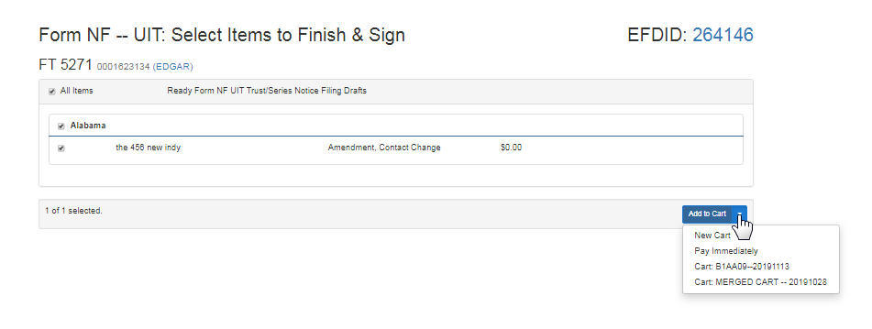

- After clicking “Add to Cart” you will be taken to the Payment Cart Details page. Here you can fill out who is paying for this notice and the main contact in the event the regulator or support need to call the filer. When you’re ready to make a payment in the system click “Next”.
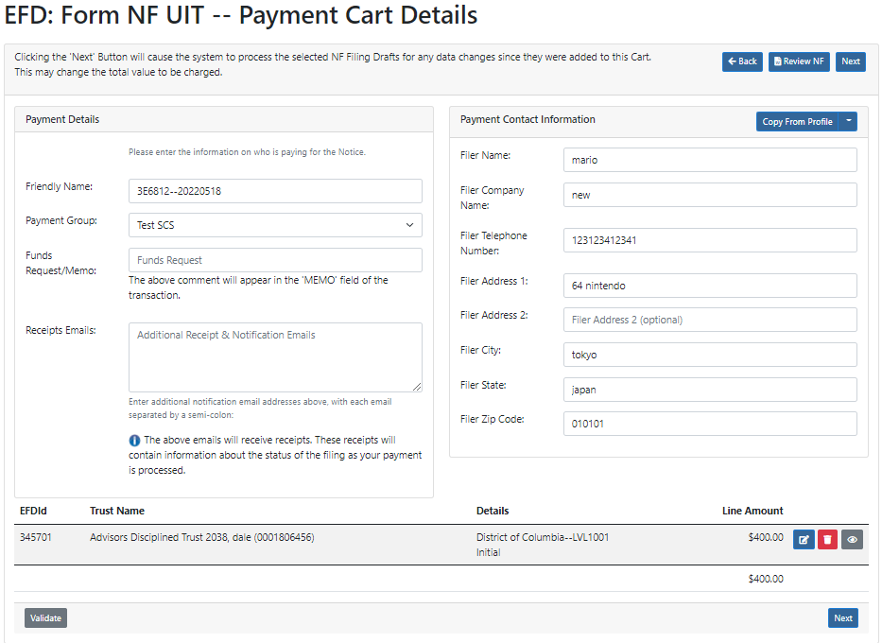
- The Confirmation page will have you look over everything you inputted in step 4. If everything is correct you will click “Next”. If something is incorrect click “Back”.
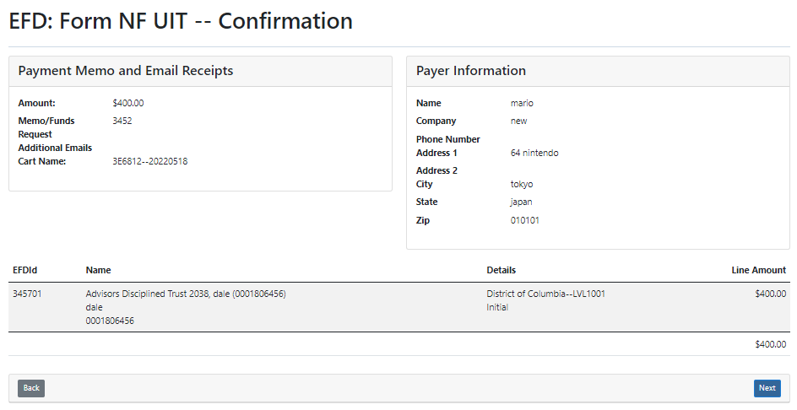
- The purpose of the ACH Payment Collection page allows the filer to make payments by ACH. That is a U.S. Account and Routing number that allow for debiting on the checking account. Not all financial institutions allow ACH Payments. You will want to verify with your bank and accounting department to ensure you’re able to make an ACH payment. When you’re ready click the check box for “I agree with the below terms” and click “Make Payment”.
- If you are using a business account you can proceed to click “Make Payment”. However, if you are using a consumer account you will need to obtain an Authorization code from EFD Support 601-453-1979.
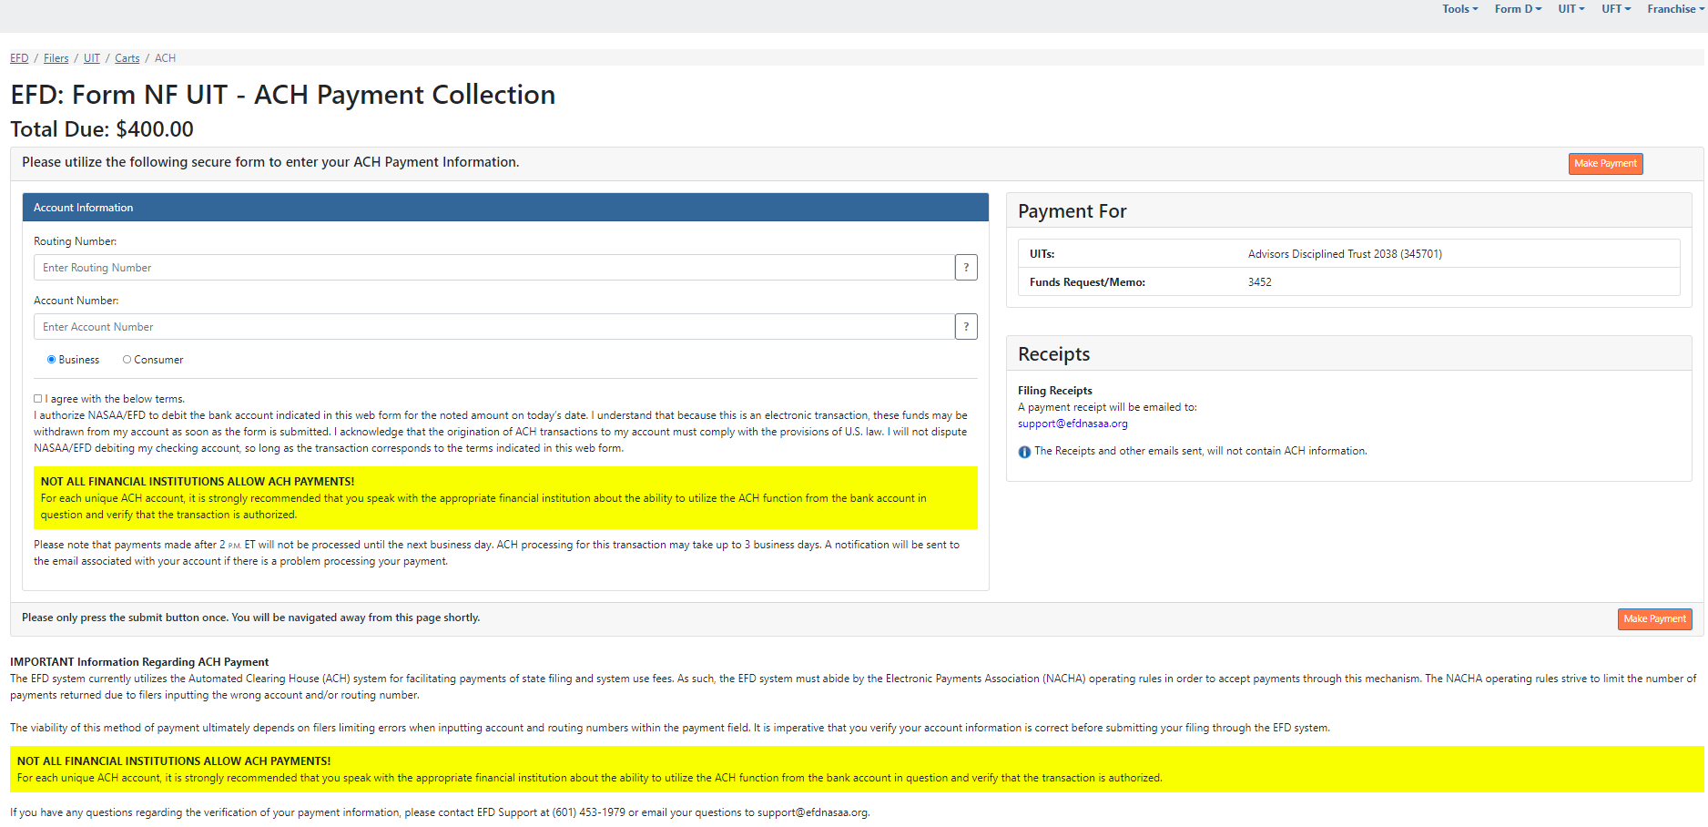
- After clicking “Make Payment” The payment is then scheduled and a receipt is sent to the primary email address listed on the account of the filer who made the payment. The receipt is proof of being filed unless there is a deficiency in payment or regulatory action is made against the filing.
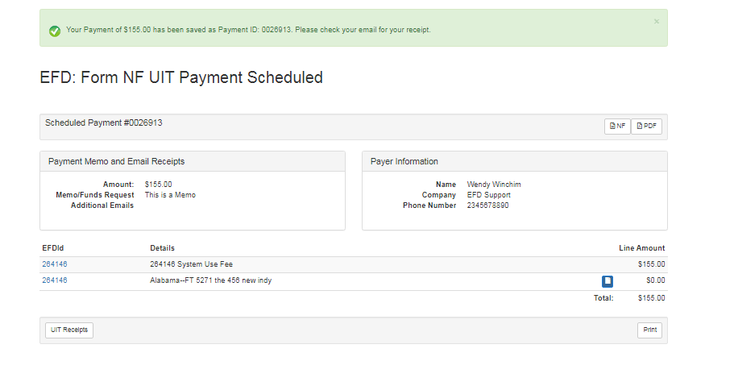

Questions:

NASAA EFD Support
601-453-1979
support@efdnasaa.org
Support Hours
8/9 am EST – 5/6 pm EST
Excluding National Holidays

