EFD Franchise Walkthrough

Navigate to the website https://www.efdnasaa.org to begin.
This document shows filers how to create a Franchise Filing.
Contents:
Screen: Home Page 2
Screen: Login Screen 3
Screen: Accept Terms and Conditions 4
Screen: Filers Home 5
Screen: Filers Home – Franchise Menu 6
Screen: Franchise - Draft Filings (NEW) 6
Screen: Franchise – Registration 8
Screen: Franchise – In Progress Filings (Banners and Messages) 11
Filer - Franchise Walkthrough 12
Screen: Franchise ACH Payment Collection 18
Questions: 20

Screen: Home Page
This is the home page for the Electronic Filing Depository, which is available at https://www.efdnasaa.org.
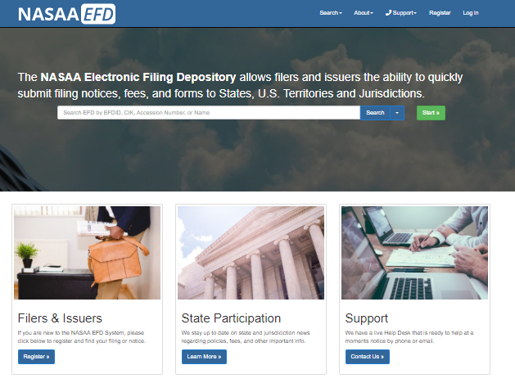
Filers must complete the registration process in order to create a new account (see the Filer Registration document).
If a Filer already has an account with EFD, then the Filer clicks Log In at the top of the screen.

Screen: Login Screen
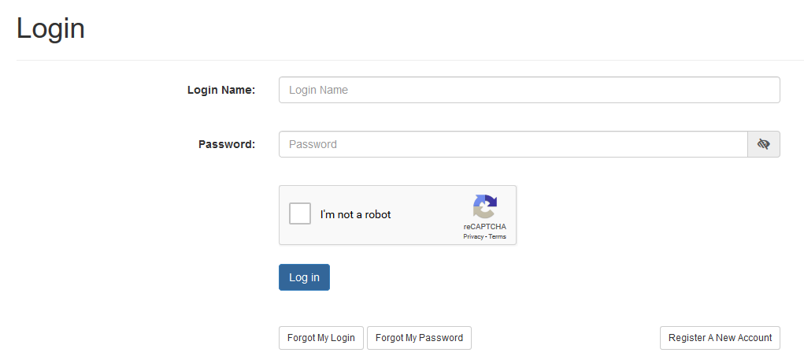
- The Filer must enter their Login Name and Password.
- The Filer must select the ‘I’m not a robot’ option, and pass any reCAPTCHA authentication.
- The Login Name IS NOT case sensitive.
- The Password IS case sensitive.

*Use the option buttons at the bottom of this screen to retrieve lost Login Names or reset your Password.
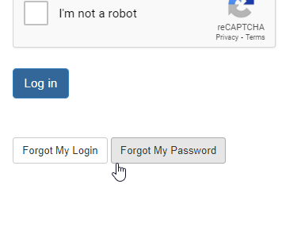

Screen: Accept Terms and Conditions
Filers must click the Accept the Terms and Conditions button upon logging into the EFD website.
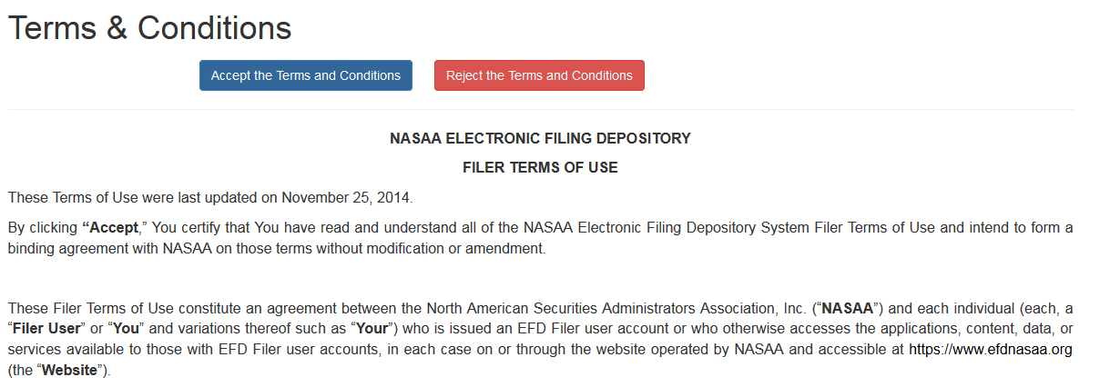

Filers will not be allowed to proceed until the Terms and Conditions on this screen are accepted.

Screen: Filers Home
After accepting the Terms and Conditions, Filers are logged in and the Filer’s Login Name will appear at the top of the screen. To get back to this page at any time you only have to click on your name/username in the top right and click on “Filer Home”.
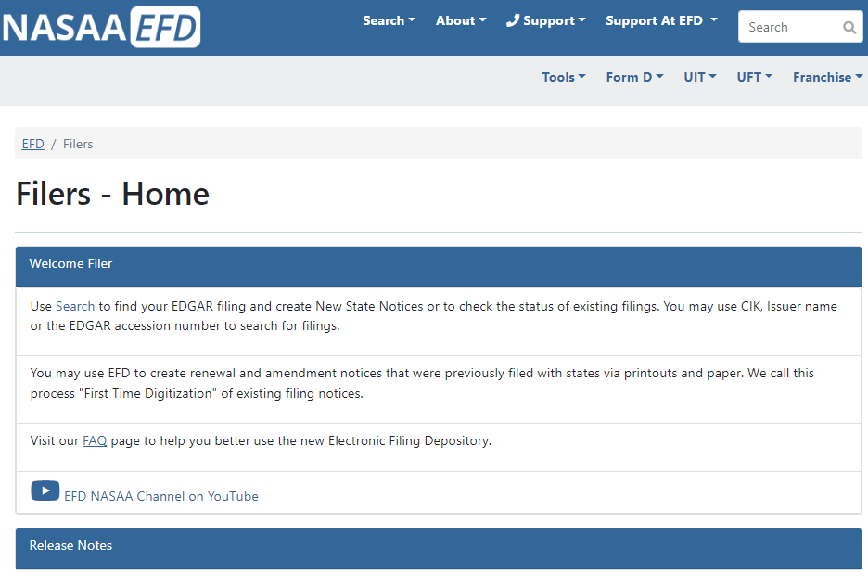

Screen: Filers Home – Franchise Menu
This menu allows one to create “NEW” franchise filings, Review franchise filings that are in progress, Active/ Inactive franchise filings, and make payment VIA Franchise CARTS. Please see the “Filer View” Document for more details.
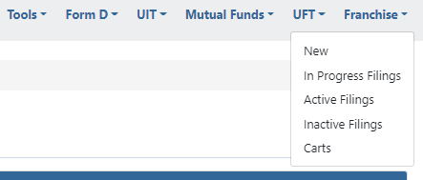

Screen: Franchise - Draft Filings (NEW)
The “NEW” section is also known as “DRAFT FILINGS”. This page allows you to create a page for your Franchise in the EFD System so you can file with the states. You can also search for already existing Franchises in the system.
For the purposes of all examples Lets use “Myrddin The Magic Card Shop”.
Once you input your Franchise Name into the entry and click “Proceed” it will search for existing franchises in the system that match. If none are found you will start a NEW draft.
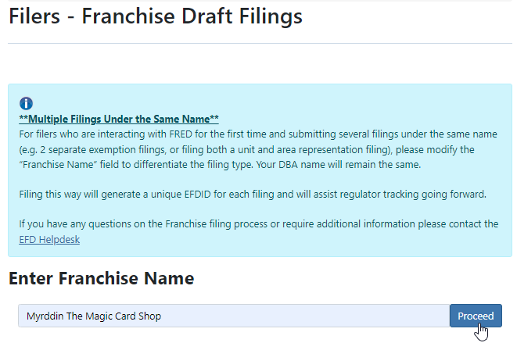

Screen: Franchise – Registration
- When a filer clicks “Proceed” on the Draft Filings page and the Franchise is new to the system, then that filer is required to complete the registration process for the Franchise. 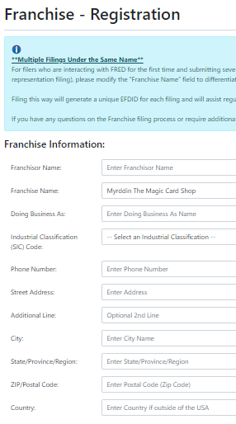
- The Filer will provide the following data points: Franchisor Name, Franchise Name, Doing Business As (DBA), SIC code, Phone Number, Street Address, City, State, Zip, and Country.
- The SIC code is a 4 digit code that is assigned by the U.S. Government to identify the primary business. If you do not know what your SIC code is then you can find out by using the SIC code website SIC Code and NAICS Code Search | SICCODE.com .
- When you click “NEXT” you will be asked to provide Contacts. Click “Add New Contact”.
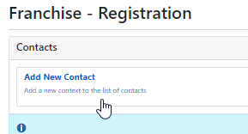
  - You can have as many contacts as you like but be sure to provide at least one primary contact.
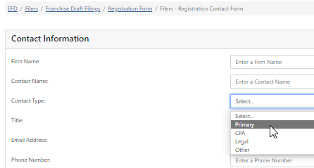
- After filling out the Contact Information click “SAVE” then to create the franchise click “NEXT”
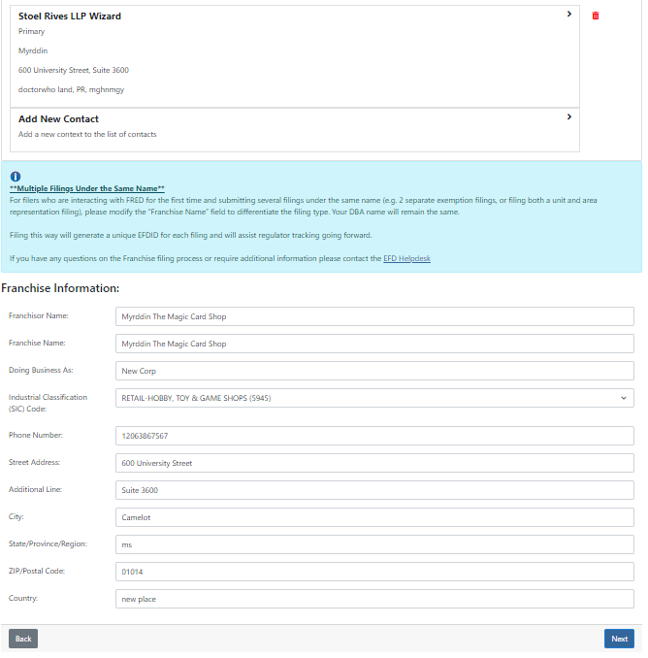
- The next page “Franchise Review” will ask you to Review what you entered before clicking “Create Filing”. If correct, then click “Create Filing”

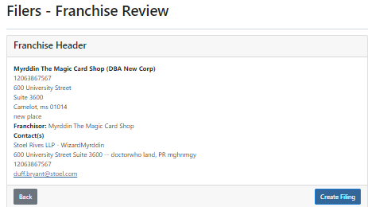
- Congrats! You created a Franchise In-Progress filing! See the Franchise Walkthrough Steps below.

Screen: Franchise – In Progress Filings (Banners and Messages)
The In Progress Filings area allows filers to make new franchise applications in states for various franchises and review responses from the states.
- After you click on “In – Progress Filings” you will be show a list of your franchise filings that you have ownership of.
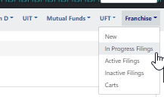
- In Progress Filings will appear alphabetically descending (A-Z).
- Banners may appear on a Franchise in this section to notify you of something. The banner may say but not limited to:
  - Current Application is Past Due
  - Current Application is Past Due – Waiting for Response
  - Regulator is Waiting for a Response
  - Franchise is Expired or Expiring Soon
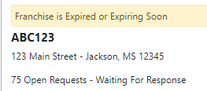

Filer - Franchise Walkthrough
This section will show you how to create a Franchise Application for a “NEW” and/or Existing Franchise Application.
- Click on Your Name/Username in the top Right.
- Click on Franchise – In-Progress Filings
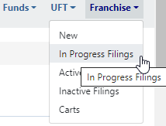
- Click on the Franchise
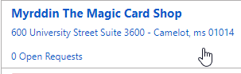
- The Franchise Overview is broken up into 5 parts (Franchise Details, Contact(s), Draft/Add New Application, Currently Effective, and Not Effective).
  - You will click on “+ Add New Application”
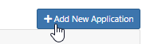
- Select your Application Type: Initial and Renewal are the primary types. Additional types can be selected from under the “Other Types” drop down. For this example I am picking “Initial”.
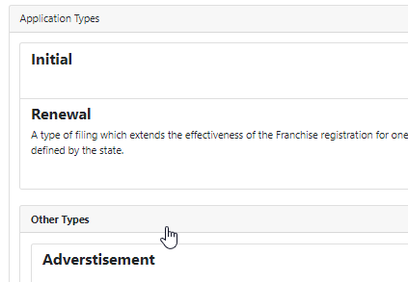
- Select your state(s). Click “Next” when you are finished. You can add/check more states or remove/uncheck states later by clicking on the “+Add Jurisdiction button”.
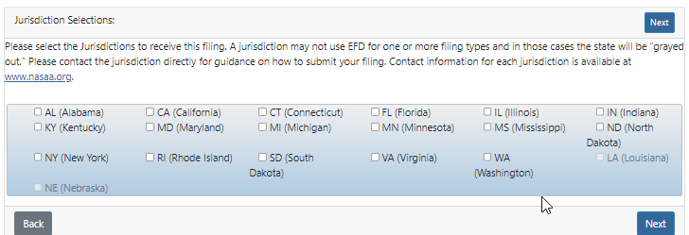
- Select your state in the left hand side to display its open requests and Draft Details.
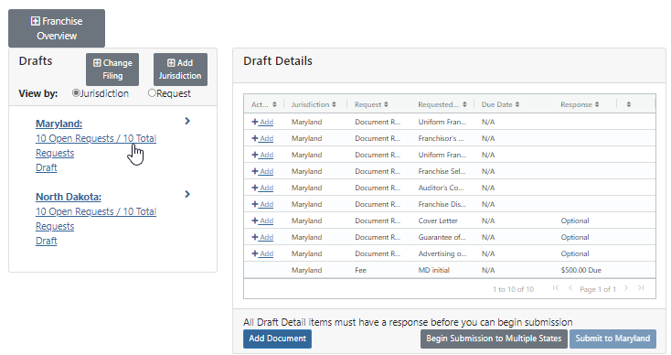
- Click “+Add” next to each Document Request to begin uploading.
  - Then you will upload the document and click “Save Response”
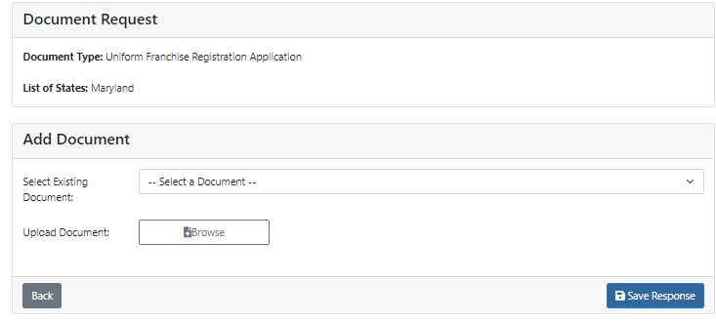
  - Make sure the document uploads 100% and turns Green before clicking “Save”
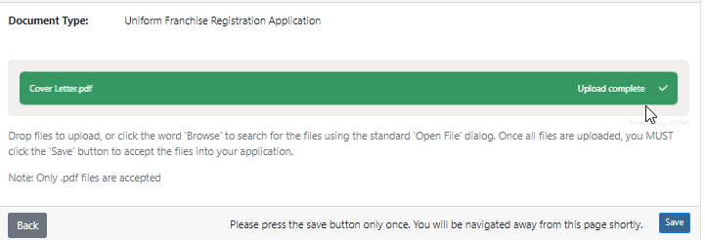
  - Click Save “Save Response” one more time to add this to the Document Request.
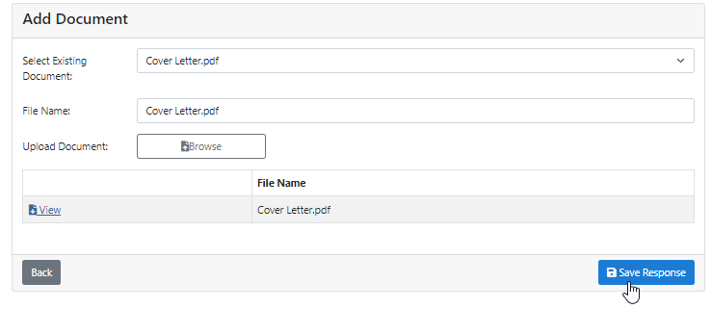
- When you have completed a request the “+Add” to the left of it disappears then a “View” appears to the right of it. This “View” allows you to see the document you uploaded.
- Filer can upload additional documents outside of the document requests by clicking on “Add Document”.
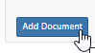
- When you have uploaded all the requested documents and there is no more “Actions” left except “Optional” then the filer can click on “Submit to [State Name]”.
  - Additionally, filers can click on “Begin Submission to Multiple States” to submit to one or more state at a time.
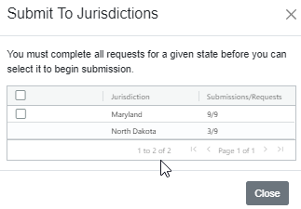
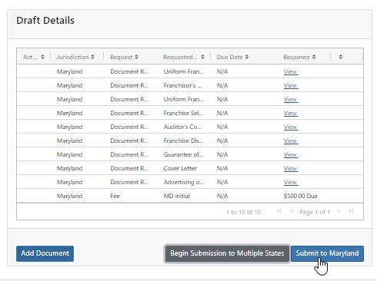
- After clicking the Submit to [State Name]” button you will need to add your state/system fee(s) to a cart. Click “Add to Cart”.
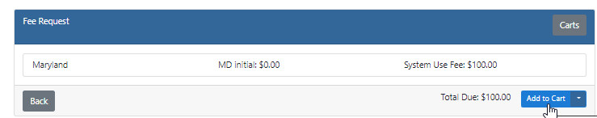
- Fill out all your Payment Cart Details ( Payment Details/Payment Contact Info) Then click “NEXT”
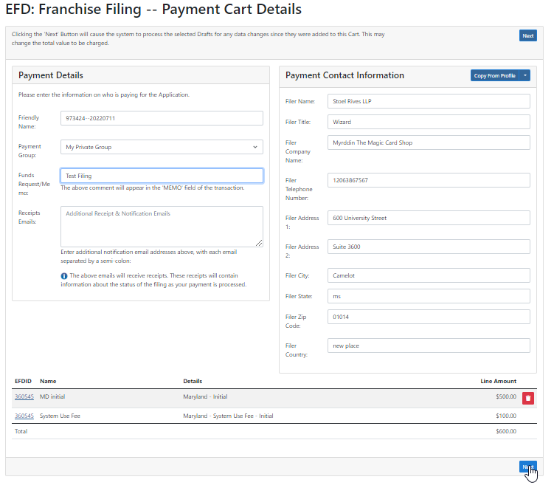
- The next page will ask that you confirm the information that you supplied on the Payment Cart Details page. If it is correct click “NEXT”.
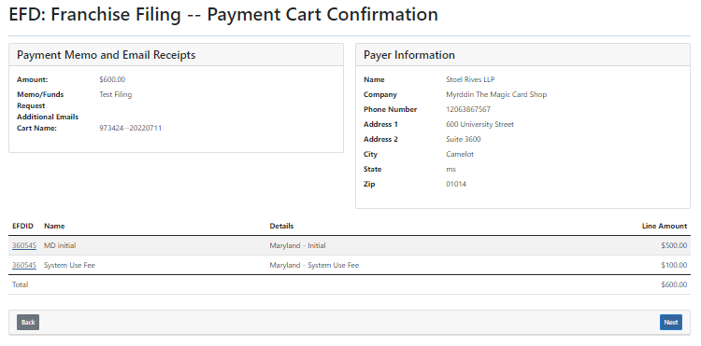

Screen: Franchise ACH Payment Collection
The ACH Payment screen allows you to securely enter your ACH payment details and submit both the filing and fees to the state. The purpose of the ACH Payment Collection page allows the filer to make payments by ACH. That is a U.S. Account and Routing number that allow for debiting on the checking account. Not all financial institutions allow ACH Payments. You will want to verify with your bank and accounting department to ensure you’re able to make an ACH payment. When you’re ready click the check box for “I agree with the below terms” and click “Make Payment”.
If you are using a business account you can proceed to click “Make Payment”. However, if you are using a consumer account you will need to obtain an Authorization code from EFD Support 601-453-1979.

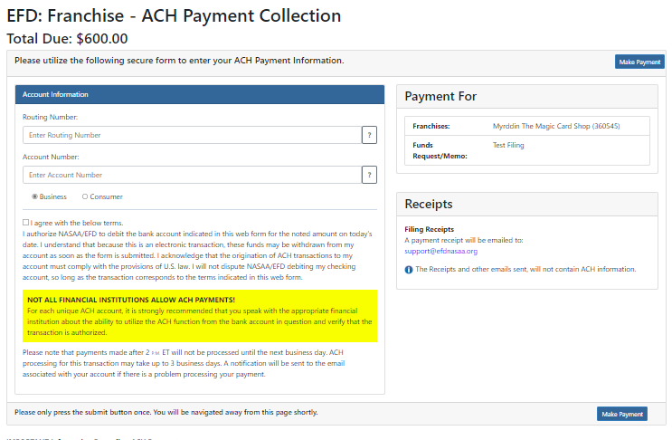
After clicking “Make Payment” The payment is then scheduled and a receipt is sent to the primary email address listed on the account of the filer who made the payment. The receipt is proof of being filed unless there is a deficiency in payment or regulatory action is made against the filing.
You will be redirected to a Thank You page.
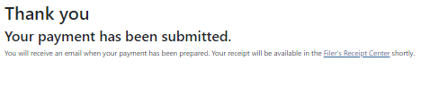

Questions:
NASAA EFD Support
601-453-1979
support@efdnasaa.org
Support Hours
9 AM EST – 6 PM EST
Excluding National Holidays

