EFD Filer Form D Walkthrough
Navigate to the website https://www.efdnasaa.org to begin.

Purpose:
This document will show how a Filer/Issuer account can create FORM D state notice filings within the EFD system.

Background:
This document assumes that you (Filer/Issuer) have already registered with the EFD system. For help with EFD registration, please see additional help documentation for Registration.
Contents:
Purpose: 1
Background: 1
Screen: Home Page 2
Screen: Login Screen 3
Screen: Accept Terms and Conditions 4
Screen: Home Screen Logged In 4
Screen: Search – FORM D 6
Screen: Search Results 7
Screen: View Filing 8
Screen: Add Notice 9
Screen: New Notice State Selection 10
Screen: Sales Report Entry 12
Screen: Classes of Securities 13
Screen: Filer Information 15
Screen: Issuer Information 16
Screen: New Notice Confirm Details 17
Screen: ACH Payment Collection 18
Questions: 19

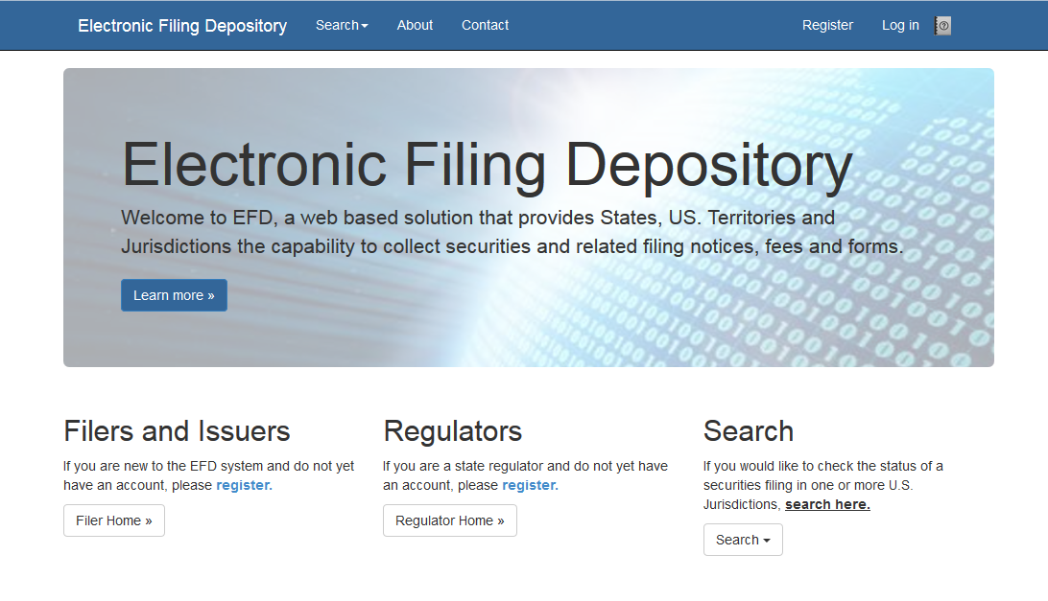
Screen: Home Page

This is the home page for the Electronic Filing Depository, which is available at https://www.efdnasaa.org.
Filers must complete the registration process to create a new account if they do not already have an account at EFD.
If a Filer already has an account with EFD, then the Filer clicks Log In at the top of the screen.

Screen: Login Screen
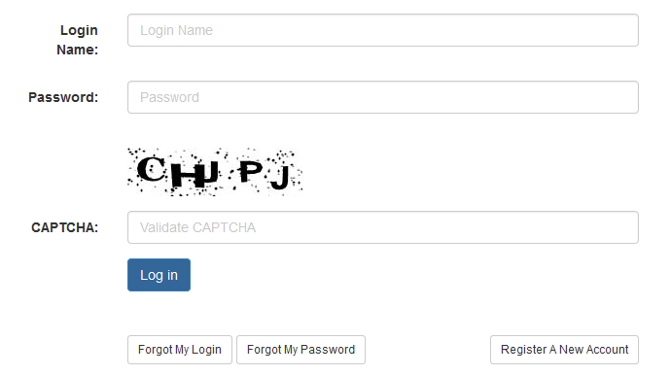

The Filer must enter their Login Name and Password and enter the CAPTCHA text where required.
The Login Name IS NOT case sensitive.
The Password IS case sensitive.
The CAPTCHA IS NOT case sensitive.

Use the option buttons at the bottom of this form to retrieve lost Login Names or Passwords.

Screen: Accept Terms and Conditions
Filers must click the Accept the Terms and Conditions button upon logging into the EFD website.
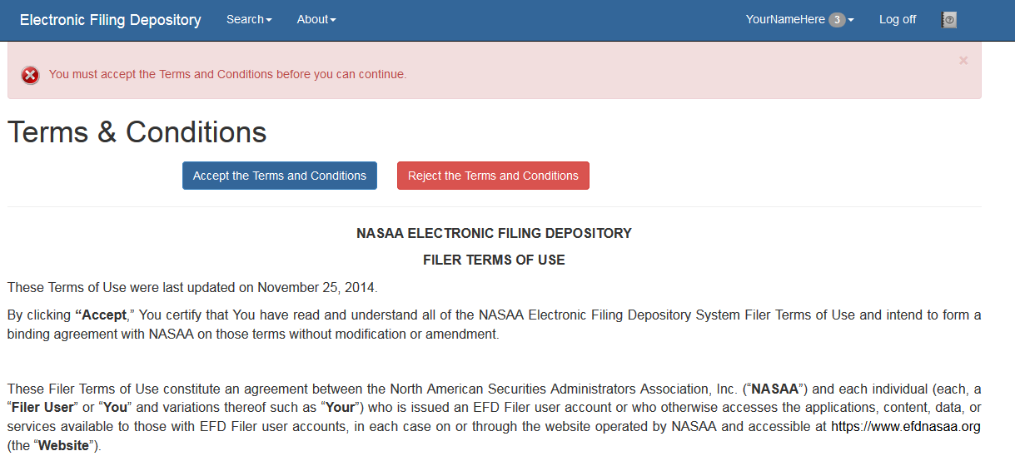

Filers will not be allowed to proceed until the Terms and Conditions on this screen are accepted.

Screen: Home Screen Logged In
After accepting the Terms and Conditions, Filers are logged in and the Filer’s Login Name will appear at the top of the screen.
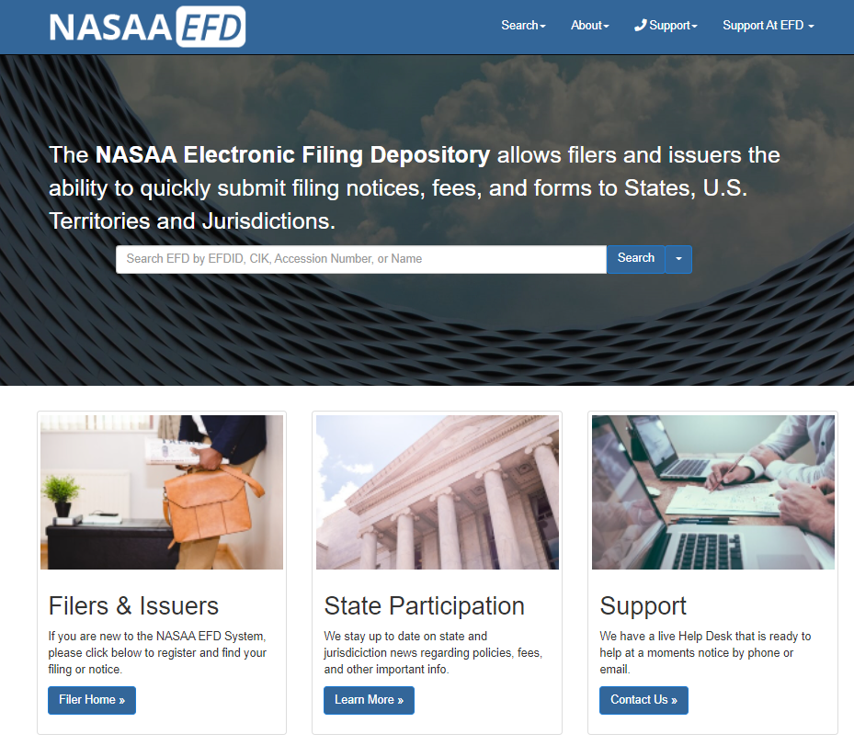

Filers may now begin the notice creation process.
Click the Search on the blue bar above and select Form D Search.
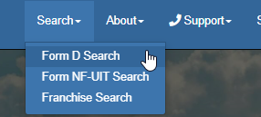

Screen: Search – FORM D
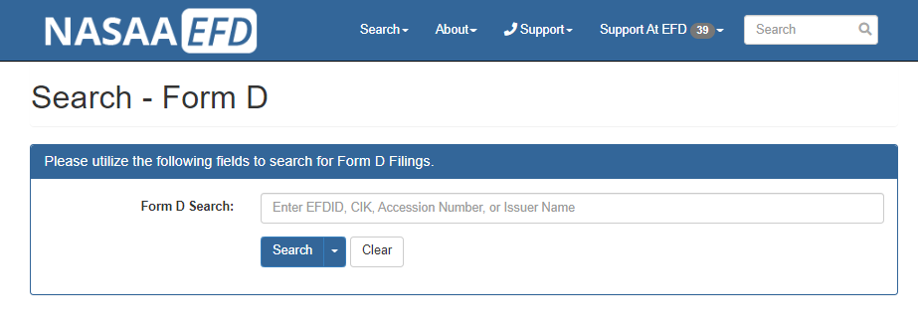
The Form D Search utility is used to search for the Form D Filing. Filers may use a variety of search criteria in the search input box including:
- Issuer CIK Number (Central Index Key)
- Issuer Name
- Accession Number
- EFD ID - Each Form D offering is assigned a unique EFD ID by the system that will follow the offering throughout its lifespan including amendments, renewals, terminations and withdrawals. The EFD ID ties associated accession numbers together and differentiates between offerings and offering series.
Filers may also use the drop down on the Search button to define what they are searching for. Filers may select from the following search criteria options:
- CRD Number
- Recipient Name
- Related Persons
- State File Number
- Signatures (as reported on the EDGAR Form D)
The search results are limited to show only the first 100 results. If more than 100 results are found, the total number of matching results is provided above the results list and can be accessed by navigating to the next page of results.

Screen: Search Results
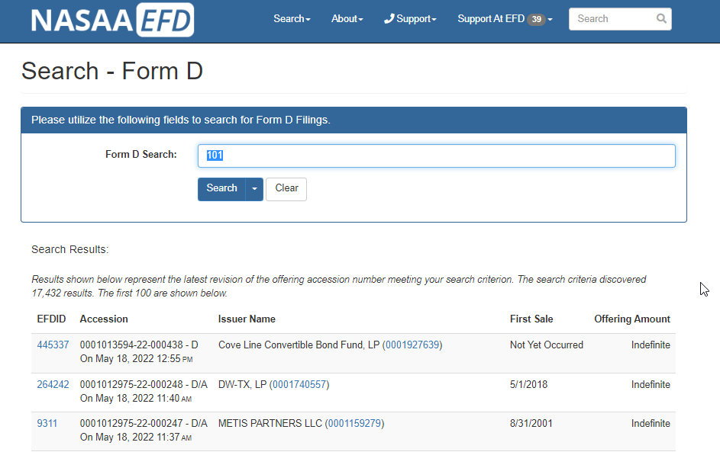
By clicking Search, Filers are provided with their search results. Click the EFD ID link to view the data retrieved from EDGAR.

Screen: View Filing
Clicking the EFD ID brings the Filer to the View Filing screen. The View Filing screen displays information that was downloaded from EDGAR by EFD. This data is stored within EFD and includes the actual Form D HTML links. 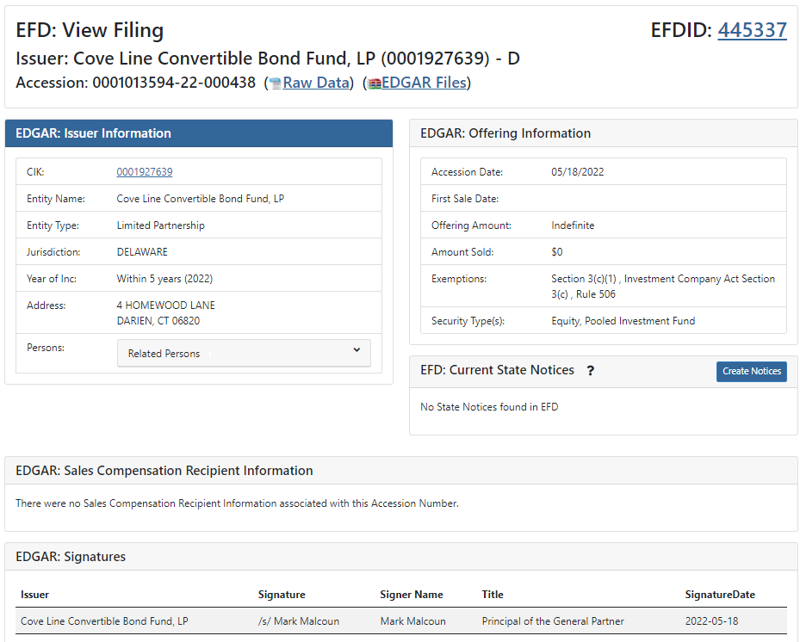Once the Filer identifies the correct offering, click the Create Notices button to begin the state filing process.
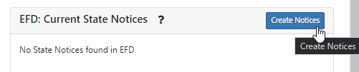

Screen: Add Notice
Clicking the Create Notices button directs the Filer to the Add Notice screen. The Filer must select which type of notice to be filed. For this example, the Filer selects a New Notice.

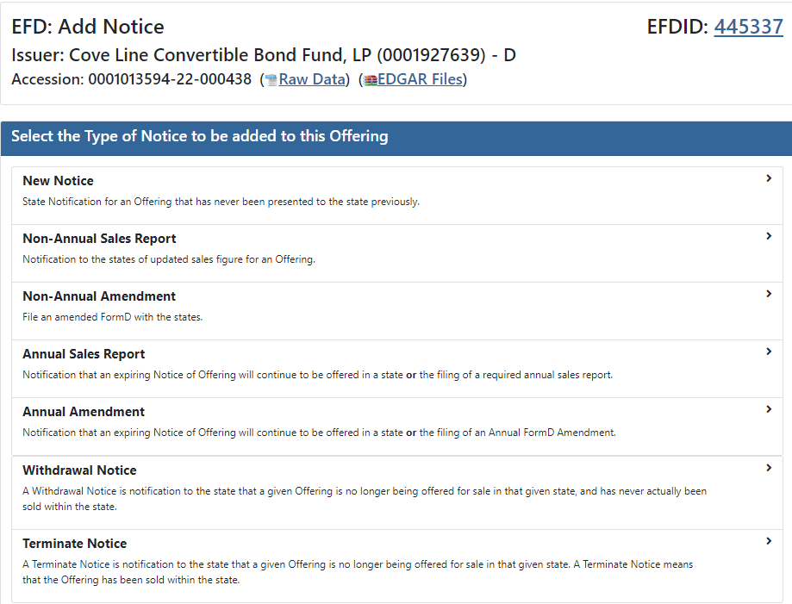

Screen: New Notice State Selection
Next, the Filer will use the checkboxes in the State Selection screen to indicate which U.S. jurisdictions they are filing in. In this example, the Filer selected District of Columbia.
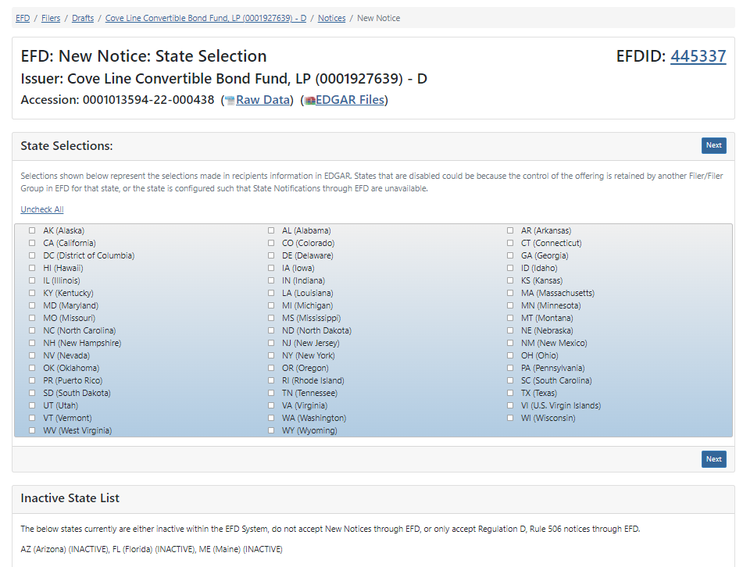

Click Next to proceed to the next step.

Screen: New Notice- Service of Process
Filers must accept and agree with the Consent to Service of Process before continuing to the next step.
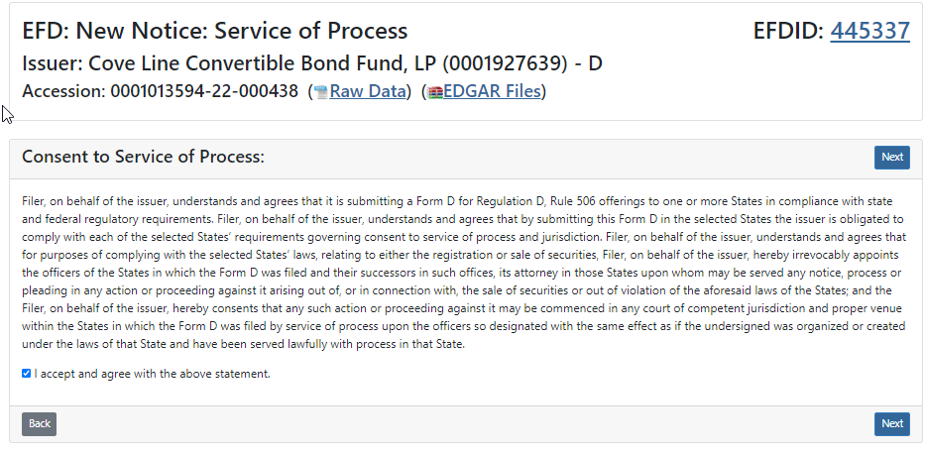
Check the box indicating that you accept and agree with the above statement and then click Next.

Screen: Sales Report Entry
The sales report screen allows Filers an opportunity to enter sales report information specific to the jurisdictions they are filing in. If the Filer selected more than one U.S. jurisdiction they will see more than one U.S. jurisdiction listed below. Each row of input boxes is designed to collect sales report information specific to the respective U.S. jurisdiction.
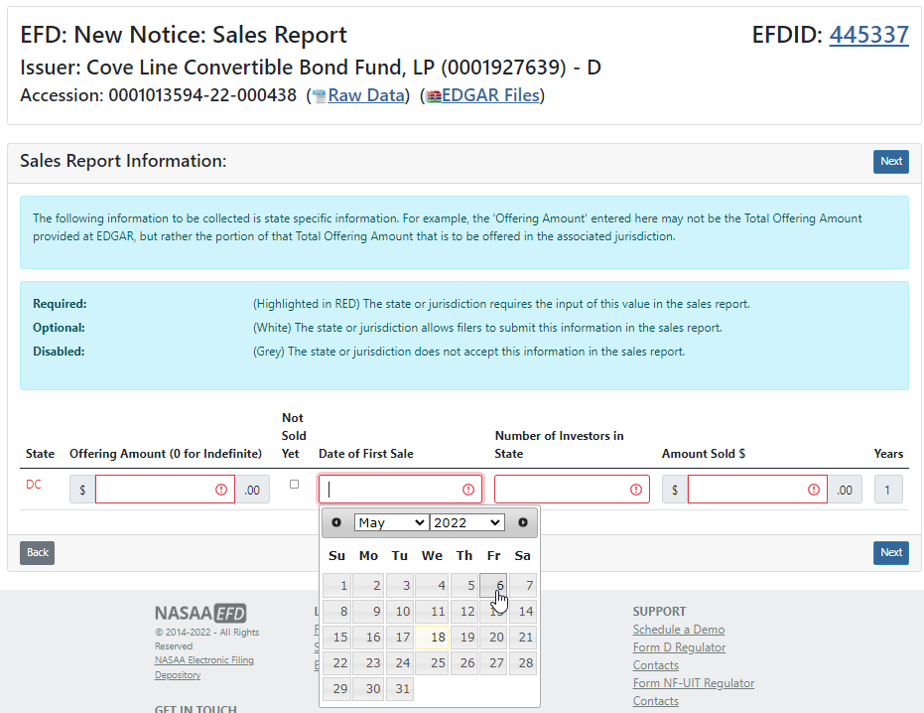

Each U.S. jurisdiction may have different input requirements for Sales Reports.
Required:
(Highlighted in RED) The state or jurisdiction requires the input of this value in the sales report.
Optional:
(White) The state or jurisdiction allows filers to submit this information in the sales report.
Disabled:
(Grey) The state or jurisdiction does not accept this information in the sales report.

Sales Reporting Terms -
Offering Amount - The amount of the offering being offered within that U.S. jurisdiction. Enter “0” if the offering is “Indefinite.” If “0” is entered, then the Maximum state fee will be assessed during checkout.
Not Sold Yet – Check this box if no sales have been made IN THIS U.S. JURISDICTION. The remaining fields will be disabled for input if the “Not Sold Yet” box is checked.
First Sale – Enter the date of the first sale IN THIS U.S. JURISDICITON.
Total Sales – Enter the total number of sales within THIS U.S. JURISDICTION to accredited and non-accredited investors. This is the count of the sales within the state.
Amount Sold $ - Enter the total amount sold IN THIS U.S. JURISDICTION.
Click Next to continue.

Screen: Classes of Securities
The Additional Data Entry screen provides Filers the ability to declare the classes of securities being sold. Not every U.S. jurisdiction requires this information to be collected, but for those states that do require this information, EFD will automatically prompt Filers to enter Classes of Securities with the following screen:
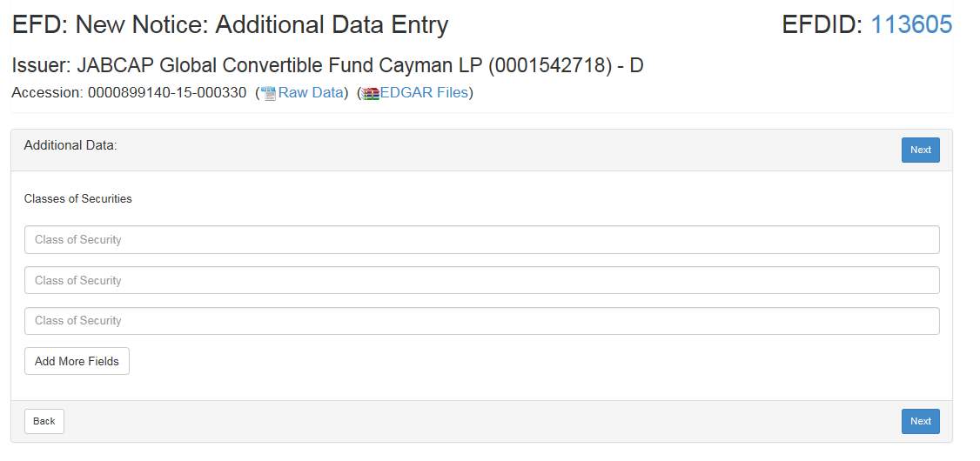
Click Next to continue.

Screen: Filer Information
The Filer Information screen collects information from the Filer to ensure a proper and secure filing payment process.
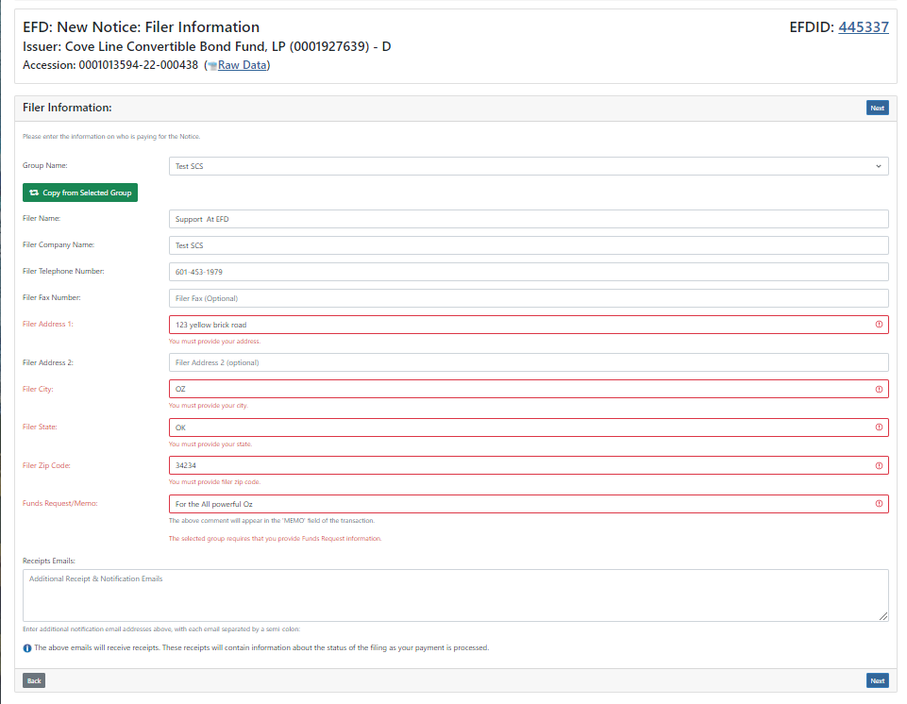
Use the Copy from Selected Group button to automatically copy this information from the Filer’s group profile. Filers may also manually enter their information.
Please note that Receipts Emails are used as a way for additional people to be notified by EFD via email about the filing of these notices. These additional email addresses will also be sent information when a notice is expiring. This information is only visible to the Filer, the Filer group administrators and the regulators within the states the Filer is filing in.
Additionally, Funds Request memo is required by some lawfirm groups to be filled out when you file. This memo appears on the receipt at the end of the filing process.
When you are ready click Next to continue.

Screen: Issuer Information
The Issuer Information screen collects information related to the Issuer/company.
Much of the information requested on this screen already exists on the EDGAR Form D filing. Use the Copy from Offering button to automatically copy the information into the fields below. Filers may also input this information manually.

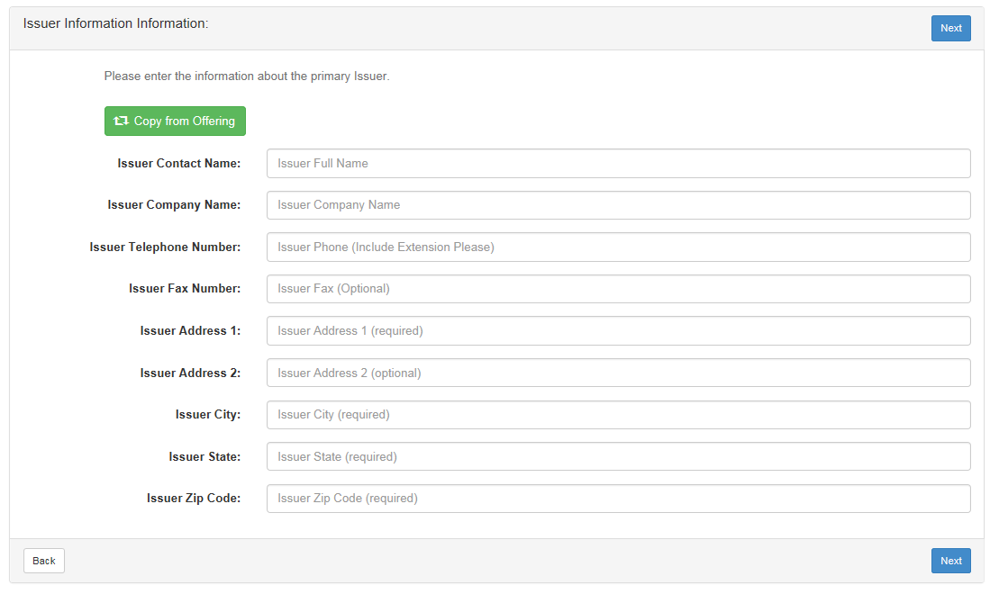
Click Next to continue.

Screen: New Notice Confirm Details
The Confirm Details screen is provided as a way for Filers to confirm their input entries and to review the fees being assessed by the EFD system. If applicable, late fees and penalties will also be included on this screen.
The Standard EFD System Use Fee is assessed one time in the lifetime of each offering (1 x Per EFDID).
At this point, Filers may choose to perform the following actions:
- Print – Print for your records
- My Drafts – Jump to the Filer’s Drafts page.
- Pay Now – Use this form to submit an ACH payment. Please note that EFD currently only accepts ACH payments.
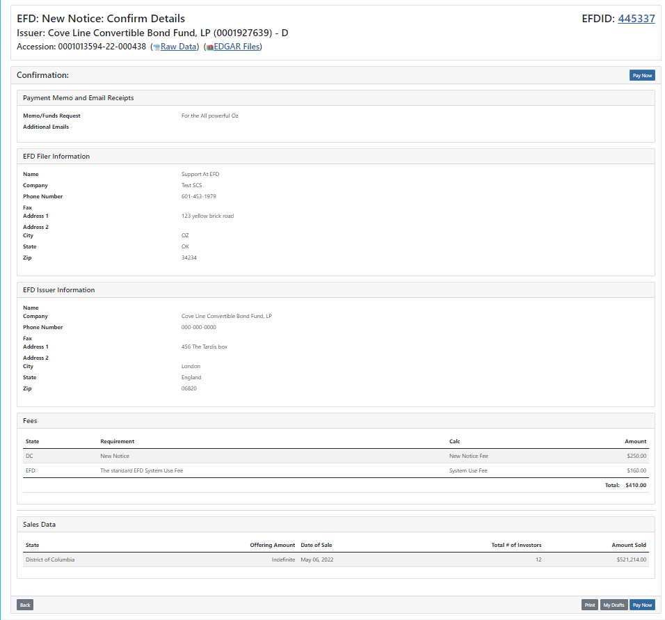
Click Pay Now to finalize the notices.

Screen: ACH Payment Collection
The following screen collects ACH payment information. Enter the Routing Number and Account Number. Please note that EFD will not save this information, and that Filers will be required to enter this information each time they wish to submit a payment.
To process an ACH payment you will need to provide U.S. Bank Routing and Account numbers, Select what type of account it is (business or consumer), and Agree to the terms. Once this is completed you can click “Make Payment”.
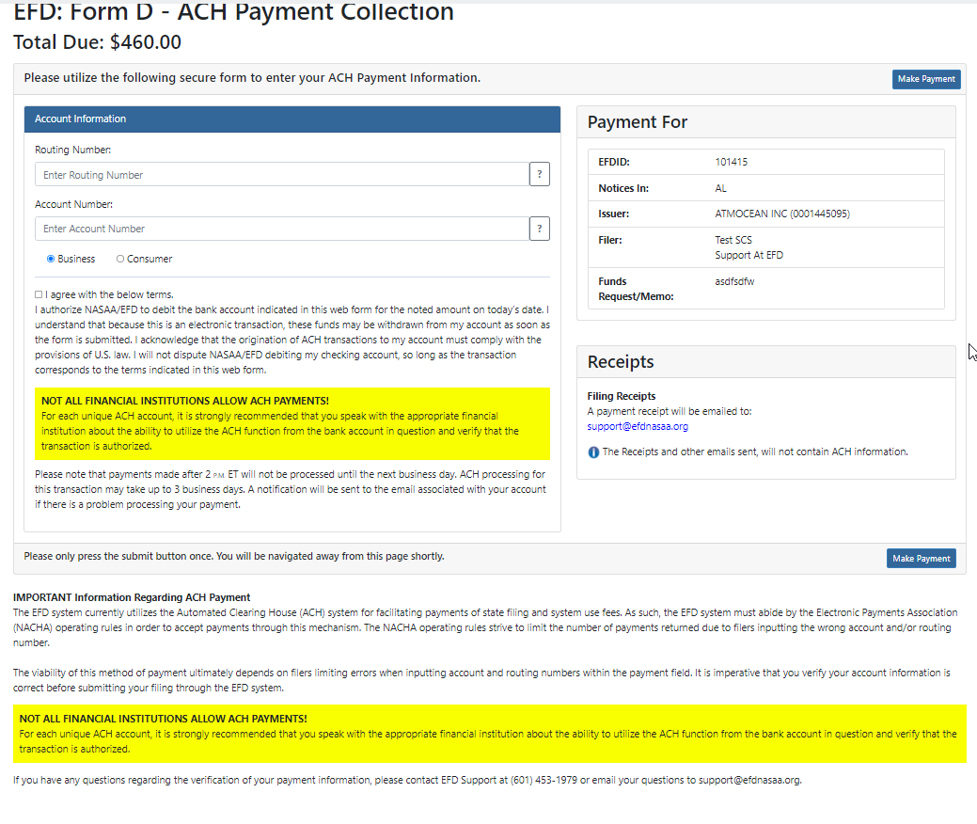
*NOTE - If your type of account is a “CONSUMER” account then you will need to call EFD Support 601-453-1979 to get an Authorization Support code to proceed.
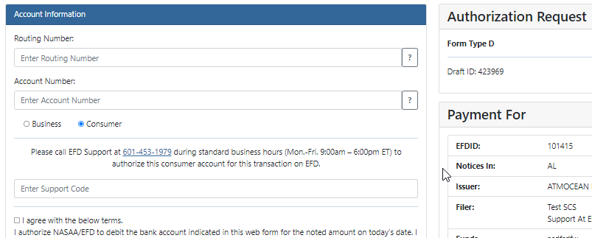
When you call in to EFD you will need to provide the DRAFT ID to obtain your Support Code. EFD will then Email you the Authorization Support code.
Once the code is typed in you can proceed to click on “Make Payment”. You will receive a receipt by email that is proof of being filed unless there is a deficiency in payment connected to this filing or if the states perform regulatory action.
Filers will be notified via email if there is a problem with the payment. New Filings, Amendments and Renewal Filing Notices are considered FILED and publicly visible as ACTIVE the moment an ACH payment is initiated. If a problem arises with your payment, such as Non-sufficient Funds (“NSF”) or a Bad Account Number, then the filings will be marked as DEFICIENT FUNDS and become publicly visible as INACTIVE.
This site is a secure transaction over SSL and your sensitive data is saved in the EFD system only long enough to complete this one time ACH transaction, complying with Federal PCI regulations.

Questions:
NASAA EFD Support
601-453-1979
support@efdnasaa.org
Support Hours
Monday - Friday
9 am EST – 6 pm EST
Excluding National Holidays

