EFD Filer Groups

Navigate to the website https://www.efdnasaa.org to begin.
This document shows filers how to create and manage a EFD Firm Group.
Contents
Definitions 2
User Actions 3
Finding the User’s Groups 3
Marking a Group as Active 3
Finding a Group 5
Request to Join a Group 7
Create a New Group 8
Reassign Notice Offerings between Groups 9
Approving a Group Invitation 13
Denying a Group Invitation 14
Rejoin a Group 14
Edit My Private Group Details 16
Group Administrators Actions 16
Editing Group Details 16
Approve Join Requests 17
Deny Approved Users in the Group 19
Deny Pending Users in the Group 20
Inviting Users to Join a Group 21
Create a User for the Group 23
Change Group Super Administrator 25
Accepting or Rejecting Group Super Administrator Request 27
Screen Descriptions 27
My Groups 27
Group Search 28
Group Editor 29
Members List 30
Membership Editor 31

Definitions
Active Group The group that is the selected User Group when a user is creating a state notice filing. A user is allowed only one Active group at a time.
Group Super Administrator The user that is in charge of all aspects of a Group. A group is allowed only one Group Super Administrator at a time.
Group Administrator A member of a group that is allowed to modify the Details about a group, view any Group Notices or any Group Drafts. A group may have more than one Group Administrator.
Notice Cnt This number the total of state filings for issuers associated to this group.
Group Status This status represents if you have the ability to utilize the group or if you were recently invited to join.

User Actions
The following sections describe the functionality that a regular user will use to manage the groups they are associated with.

Finding the User’s Groups
The following steps describe the process needed to find a listing of the groups the user’s account is associated with.
- Log into the EFD Website.
- Open the User Menu found in the top-right hand corner of the screen.
- Select the My Groups option to navigate to the My Group page.
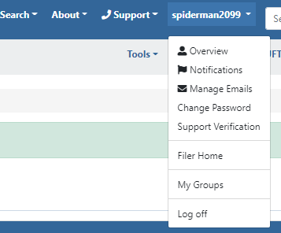
The My Groups page lists all the groups that a user is associated with, as well as the Membership Status that the user has within that group.

Marking a Group as Active
The following steps describe the process to mark a group as the Active Group.
Please note that a user will only be allowed to make a group their active group when they are a member of that group, and their membership status is ‘Approved.’
- Log into the EFD Website.
- Navigate to the My Groups page, as described in the Finding the User’s Groups section.
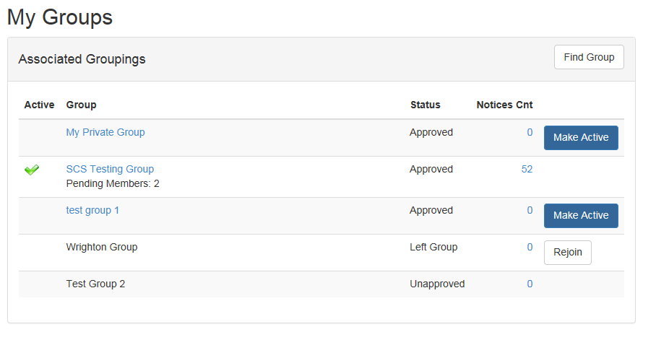
Figure 1 My Groups
- The Filer will review the list of groups that they are associated with and find the group that they wish to mark as Active.
- Select the Make Active option.

- As shown in Figure 2, EFD will display a success message at the top of the screen if the Make Active command was accepted.
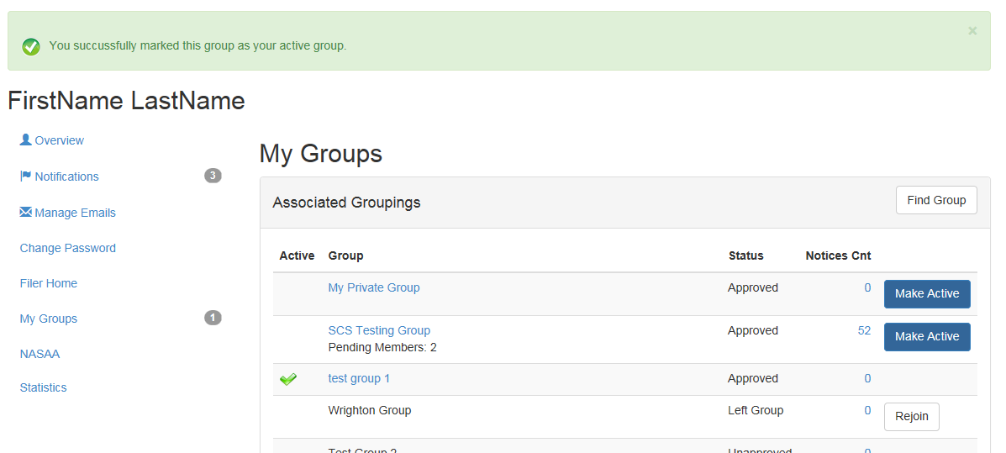
Figure 2 Make Active Command Successful

Finding a Group
- Log into the EFD Website.
- Navigate to the My Groups page, as described in the Finding the User’s Groups section.
- Select the Find Group Command as shown in Figure 3.
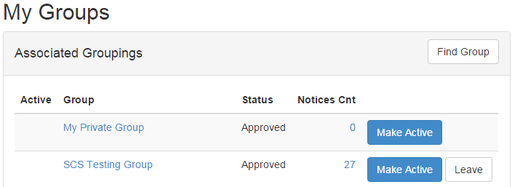
Figure 3 My Groups--Find Group Command
- Search for a group using the Group Search screen, as shown in Figure 6.

- The results of the search are displayed in the results list, also shown in Figure 4.
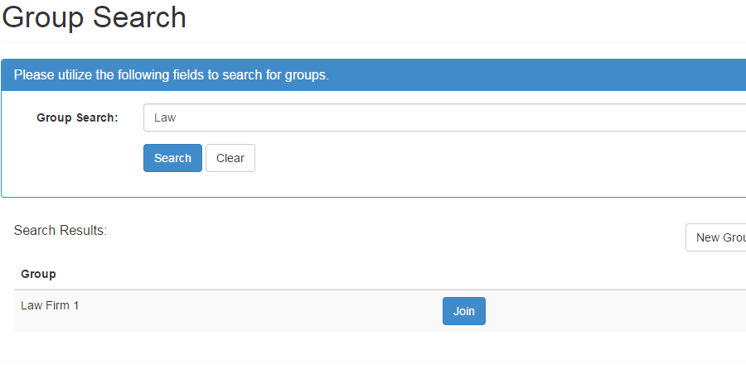
Figure 4 Group Search - Search Results

Request to Join a Group
Requests to Join a Group must be approved by the Group Administrator or other authorized user of the Group prior to a user actually being able to act as a member of the selected group.
- Log into the EFD Website.
- Navigate to the My Groups page, as described in the Finding the User’s Groups section.
- Search for the desired group as described in the Finding a Group section.
- Find the group name in the search results, as shown in Figure 4.
- Click the Join button.
- The user will be presented with a message indicating that their request to join a group has been submitted successfully. Figure 5 displays an example of that message.
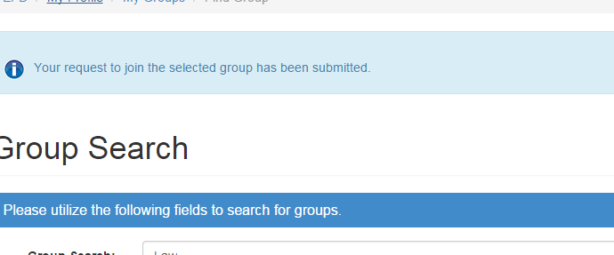
Figure 5 Request to Join Group Success

Create a New Group
- Log onto the EFD Website.
- Navigate to the My Groups page, as described in the Finding the User’s Groups section.
- Search for the desired group as described in the Finding a Group section.
- Ensure that the Group does not already exist, using the Search Results.
- Click the New Group command, as seen in Figure 6.
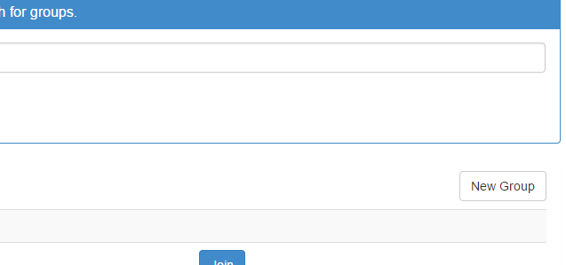
Figure 6 Group Search - New Group Command
- Fill in the New Group form as shown in the Group Editor section.
- Click the Save button.
- If the group is successfully saved, then the user will be presented with the success messages as shown in Figure 7.
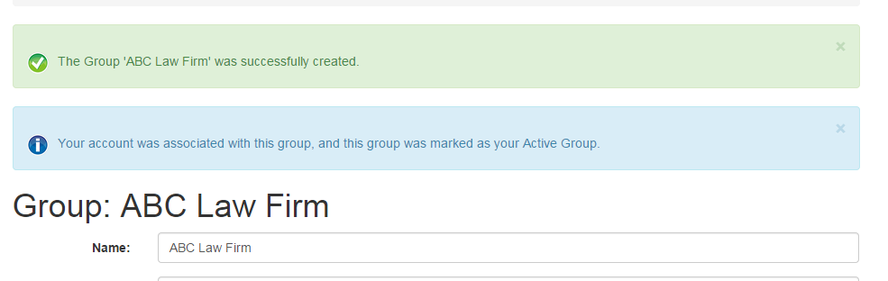
Figure 7 New Group Creation Success
After creation of a new group, an account is automatically associated with the new group, the new group is marked as the active group, and the user is assigned as the Super Administrator for the group.

Reassign Notice Offerings between Groups
Users are only able to reassign notices between groups which are associated directly with their account. This means that only those notices which they create, or that have been reassigned to them through the Reassign Notice Offerings Between Group Members tool can be accessed through this tool.
- Log into the EFD Website.
- Navigate to the My Groups page, as described in the Finding the User’s Groups section.
- Find the Group that has the notices to re-assign.
- Click the Notice Counter next to the Group Name.
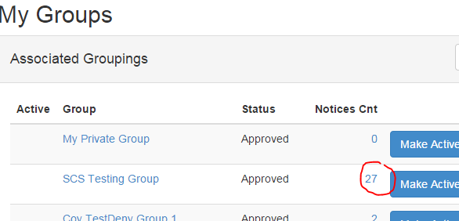
Figure 8 My Groups Notice Counter
- This will take the user to the Reassign Notices screen as defined in the Reassign Notice Offerings Between Groups section.
The Notices are grouped by the Primary Issuer as defined by the Filing at the SEC.
- Select the issuer.
- As shown in Figure 9, the screen will list the notices assigned to the account for this issuer.
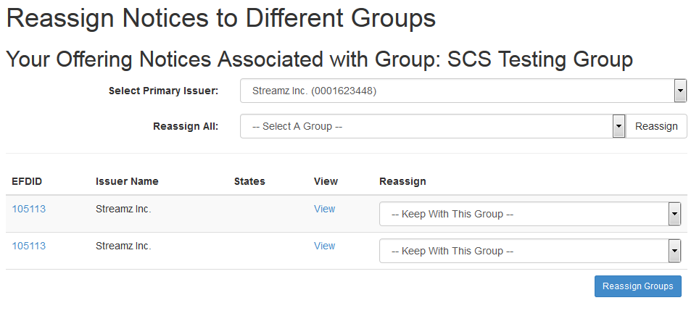
Figure 9 Reassign Notices to Groups - Selected Primary Issuer
- Select the Group to assign the notices to.

This selection can occur in two distinct ways. Using the ‘Reassign All’ drop list will re-assign all of the Notices for the selected issuer to the new group. While using the ‘Reassign’ drop list in the List will allow the user to select specific notices to go to specific groups.
- Click the Reassign button, as seen in Figure 10.
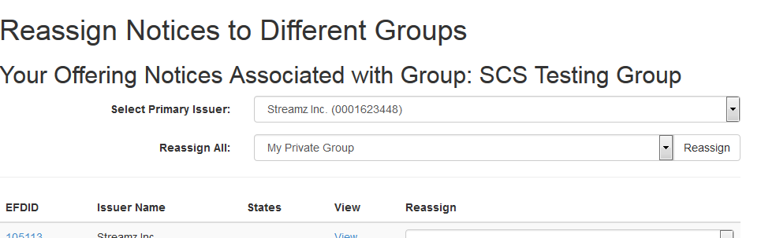
Figure 10 Reassign Group - Reassign Command
- Filers will be presented with the confirmation dialog seen in Figure 11. Select the OK button to continue.
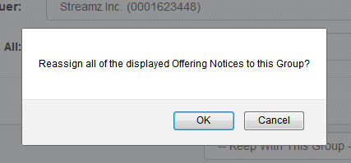
Figure 11 Reassign Group - Confirmation Dialog

- If successful, the user will be presented with a success message as shown in Figure 12.
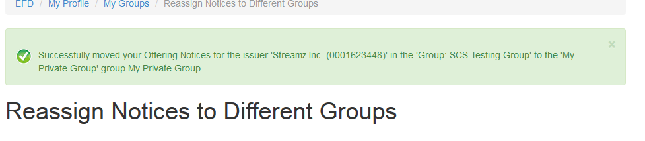
Figure 12 Reassign Group - Success Message

Approving a Group Invitation
- Log into the EFD Website.
- Navigate to the My Groups page, as described in the Finding the User’s Groups section.
- Find a Group with the status of Invited as shown in Figure 13.
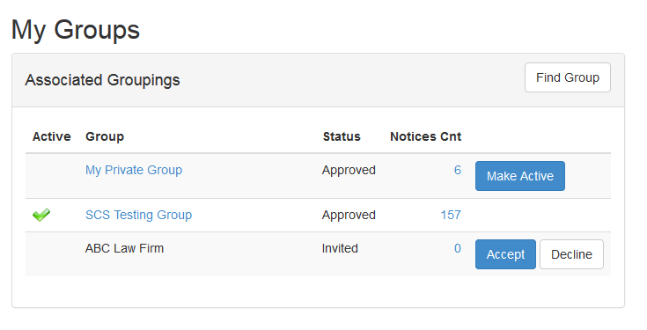
Figure 13 My Groups -- Invited Group
- Click the Accept button.
- If successful, the user will be shown a success message, an example of which is Figure 14.
Figure 14 Approve Group Invite Success

Denying a Group Invitation
- Log into the EFD Website.
- Navigate to the My Groups page, as described in the Finding the User’s Groups section.
- You will see a Group with the status of Invited as shown in Figure 13.
- Click the Deny button.
- If successful, the user will be shown a success message, an example of which is Figure 15.
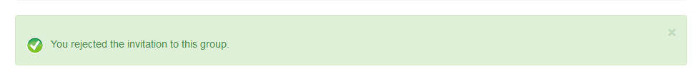
Figure 15 Decline Group Invitation Success

Rejoin a Group
- Log into the EFD Website.
- Navigate to the My Groups page, as described in the Finding the User’s Groups section.
- You will see a Group with the status of Left Group as shown in Figure 16.
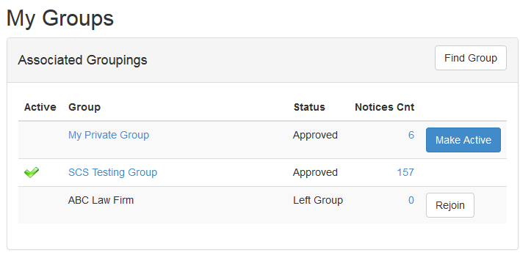
Figure 16 My Groups – Rejoin
- Click the Rejoin button.

- If successful, a success message is displayed, an example of which is Figure 17.
Figure 17 Rejoin Group - Success

Edit My Private Group Details
- Log into the EFD Website.
- Navigate to the My Groups page, as described in the Finding the User’s Groups section.
- Click the My Private Group button.
- Modify the Private Group information.
- Click the Save button.
- EFD will display a success message.

Group Administrators Actions
The following sections describe the functionality which Group Administrators will use to manage their groups.

Editing Group Details
- Log into the EFD Website.
- Navigate to the My Groups page, as described in the Finding the User’s Groups section.
- Click the name of the group to edit the details.
Only the Group Administrator may edit the Group Details.
- Modify the desired Group information.
- Click the Save button.
- EFD will display a success message.

Approve Join Requests
When a user has requested membership into the group, their account is listed under the Pending option of the Members List screen. The following steps describe how a Group Administrator would approve that membership request.
- Log into the EFD Website.
- Navigate to the My Groups page, as described in the Finding the User’s Groups section.
The My Groups Section will display the count of members waiting for approval on the My Groups Screen, if the permission set allows access to that functionality.
- As shown in Figure 1820, find the Group that has Pending Members.
Figure 18 My Group Displaying Pending Members
- Follow the link (under the name) to navigate to the Group Editor screen.
- Scroll down to the bottom of the page, and find the View Members option.
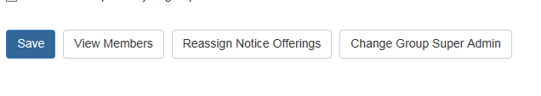
Figure 19 Group Editor Command Buttons
- Select the View Members option.
- This will navigate to the Members page for the selected Group.
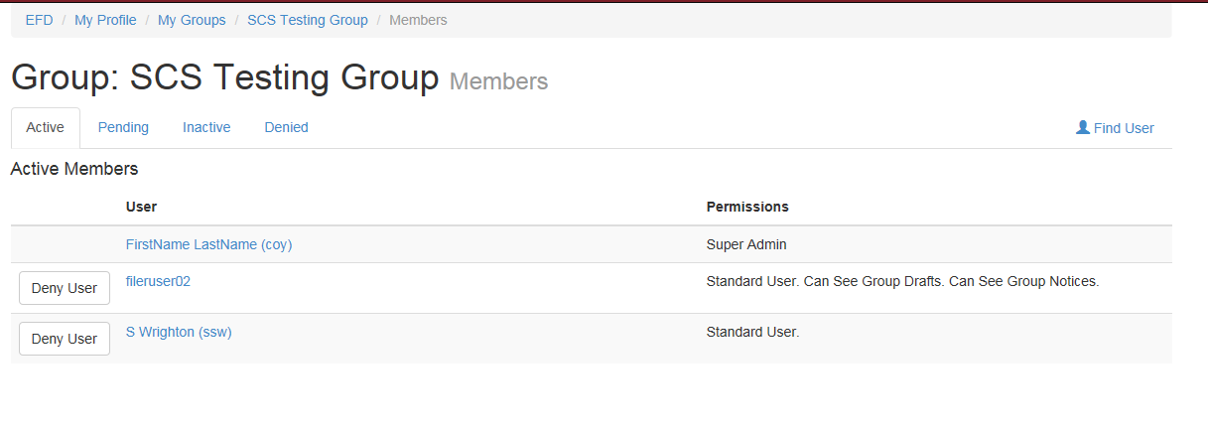
Figure 20 Group Members Page
- Select the Pending tab.
This will display those users that are currently waiting for Membership approval. If a Member was invited into the group by an Administrator, the option exists for the user to be denied from this screen, but approval is already assumed. If a user has requested to join this group, then the user must be approved before they are able to function within the group. Figure 21 displays two users whose membership for the displayed group is still pending. The first user in the figure (filertest1) was invited to join the group, while the second user requested membership.
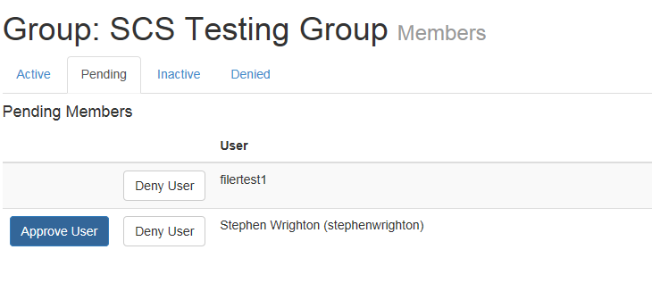
Figure 21 Pending Members Tab
- Click the Approve User button.
- If the Group Membership approval was successful, a success message is displayed at the top of the screen.
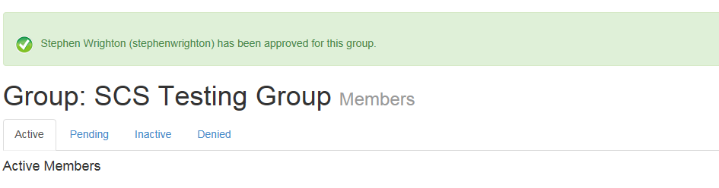
Figure 22 Approve Member Success Message

Deny Approved Users in the Group
- Log into the EFD Website.
- Navigate to the My Groups page, as described in the Finding the User’s Groups section.
- Click the Group name to navigate to the Group Editor screen.
- Scroll down to the bottom of the page, and find the View Members option.
- Find the user in the Active Members list to be set to Deny.
- Click the associated Deny button.
- You will be presented with a Confirmation Dialog. An example of this dialog as seen in Figure 23.
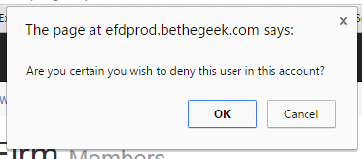
Figure 23 Deny User Confirmation Dialog
- Click the OK command.

- If the User Denial was successful, a success message is displayed. An example of that success message is Figure 24.
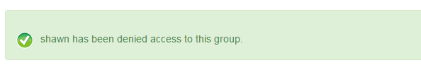
Figure 24 - Deny User Success Message

Deny Pending Users in the Group
- Log into the EFD Website.
- Navigate to the My Groups page, as described in the Finding the User’s Groups section.
- As shown in 20, find the Group that has Pending Members.
- Click the Group name to navigate to the Group Editor screen.
- Scroll down to the bottom of the page, and find the View Members option.
- Select the Pending tab.
- This action will display the Pending Members list as seen in Figure 25.
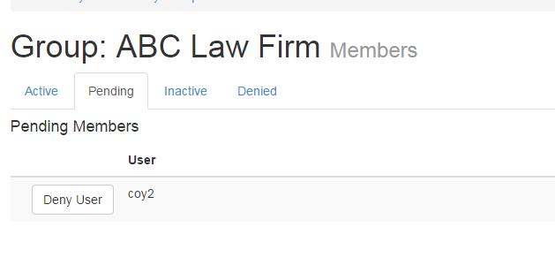
Figure 25 Deny Pending Users -Pending List
- Find the user in the Pending List and click the associated Deny button.

- If the User Denial was successful, a success message will be displayed. An example of that success message is Figure 26.
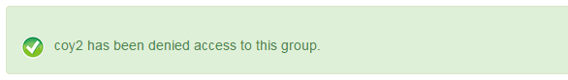
Figure 26 Deny Pending User Success

Inviting Users to Join a Group
- Log into the EFD Website.
- Navigate to the My Groups page, as described in the Finding the User’s Groups section.
- Find the Desired Group to invite Members to.
- Click the Name of the Group.
- This will navigate to the Group Editor page.
- Click the Find Members command.
- This will navigate to the Members List group.
- Select the Find User command seen in Figure 27.
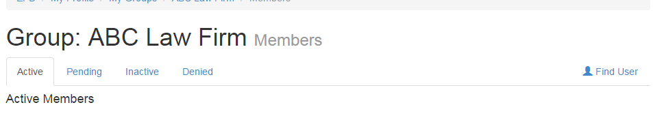
Figure 27 Find User

- Search for the user to invite, using the User Search form shown in Figure 28.
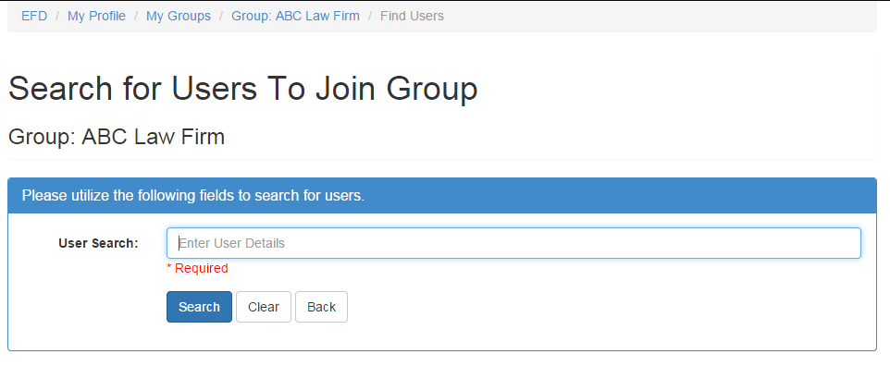
Figure 28 Find User - Search Form
- Find the desired user in the results list, an example of which is shown in Figure 29.
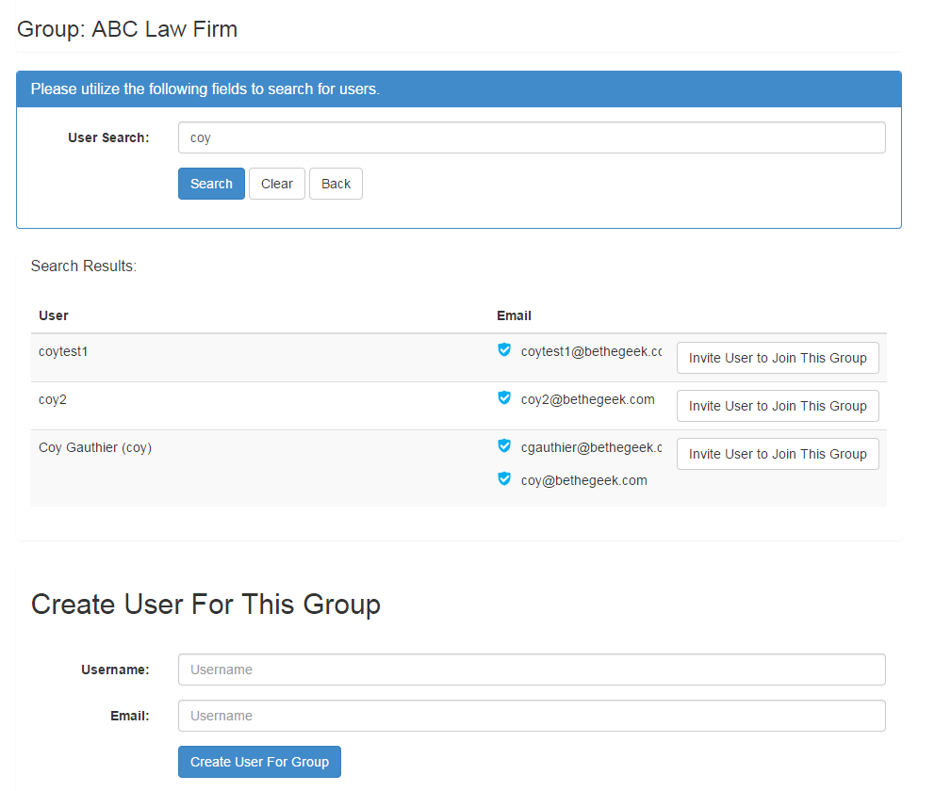
Figure 29 Find User - Search Results
- Select the Invite User to Join This Group button.

- If the user is successfully invited, a success message will be displayed as seen in Figure 30.
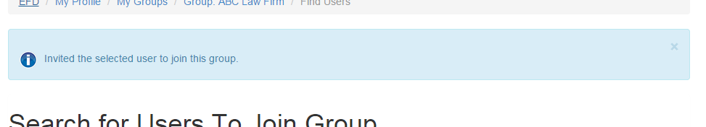
Figure 30 Invite User Success

Create a User for the Group
- Log into the EFD Website.
- Navigate to the My Groups page, as described in the Finding the User’s Groups section.
- Find the Desired Group to invite members to.
- Click the Name of the Group.
- This will take the user to the Group Editor page.
- Click the Find Members command.
- This will take the user to the Members List group.
- Select the Find User command seen in Figure 27.
- Search for the user to ensure they do not currently have an account.

- Use the Create User for this Group section, as seen in Figure 31 of the User Search Form/Results to define a new user to be invited to join the selected group.
Figure 31 Create User for Group
- Enter the Username and Email address.
- Click the Create User for Group button.

- If successful, the screen will display a success message, and perform a user search for the entered username, as shown in Figure 32.
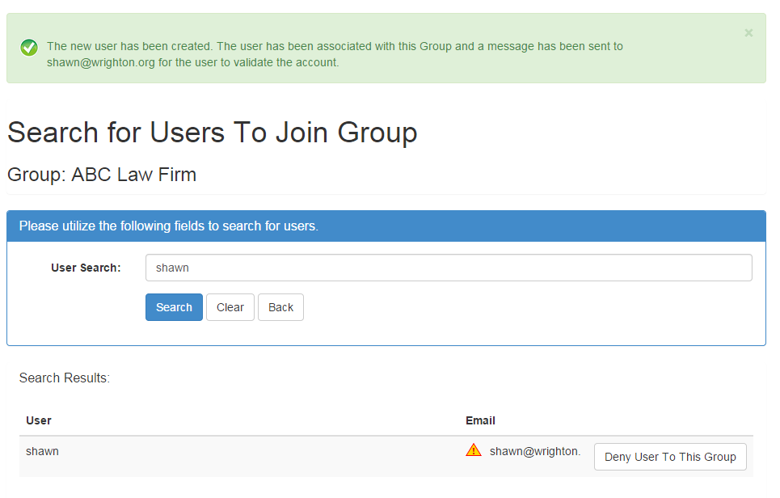
Figure 32 Create User for Group Success

Change Group Super Administrator
- Log into the EFD Website.
- Navigate to the My Groups page, as described in the Finding the User’s Groups section.
- Find the Group to change the Super Administrator for.
- Click the Name of the Group to navigate to the Group Editor for that group.

- Click the Change Group Super Admin button, as seen in Figure 33.
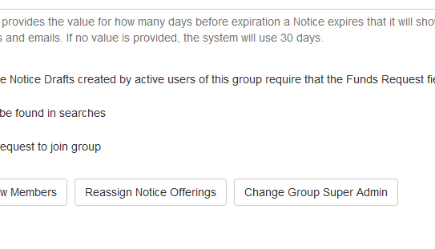
Figure 33 Change Super Admin Command
- This will take the user to the Change Group Super Admin screen.
- Select the Member that is desired to be the new Group Super Administrator.
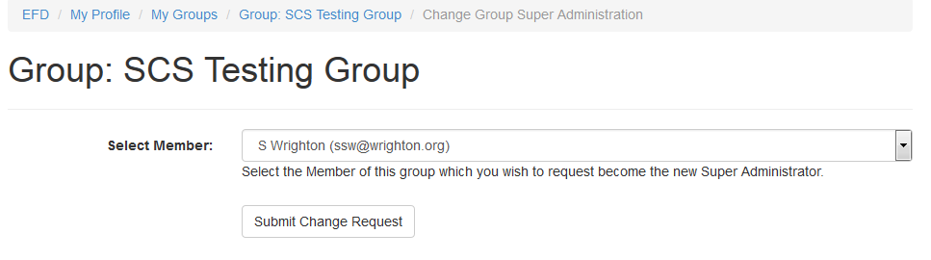
Figure 34 Change Super Admin - Select New Super Admin
- Click the Submit Change Request button.
The New Super Administrator MUST accept the role of Group Super Administrator. If the role is not accepted, then it remains with the current Group Super Administrator.
- If successful, a success message will be displayed, the user will be redirected to the Group Editor screen, as shown in Figure 35.
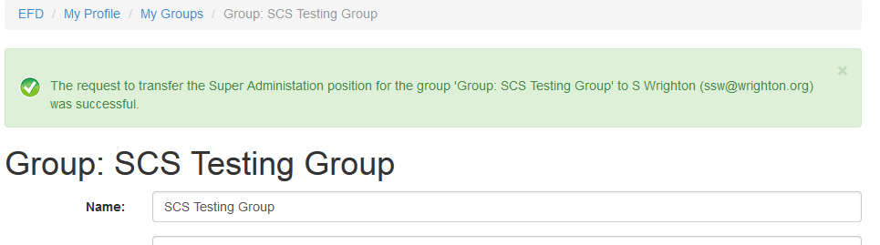
Figure 35 Change Super Admin Success

Accepting or Rejecting Group Super Administrator Request
- Log into the EFD Website.
- A message will be presented that indicates that the user has been sent a request to become the new Super Group Administrator for a group. Figure 36 displays an example of the message.
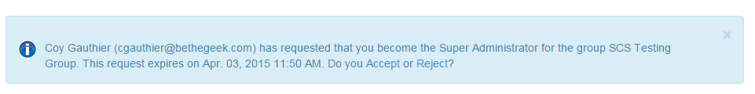
Figure 36 Super Administrator Request Resolution
- Click the Accept or Reject option in the message.

Screen Descriptions
The following sections describes the screens associated with Filer Groups.

My Groups
The My Groups screen provides a listing of the groups that a user is associated with. All Filers are always associated with at least one group (called My Private Group). This screen also allows the Filer to set the Active Group. Figure 37 displays the My Groups screen.
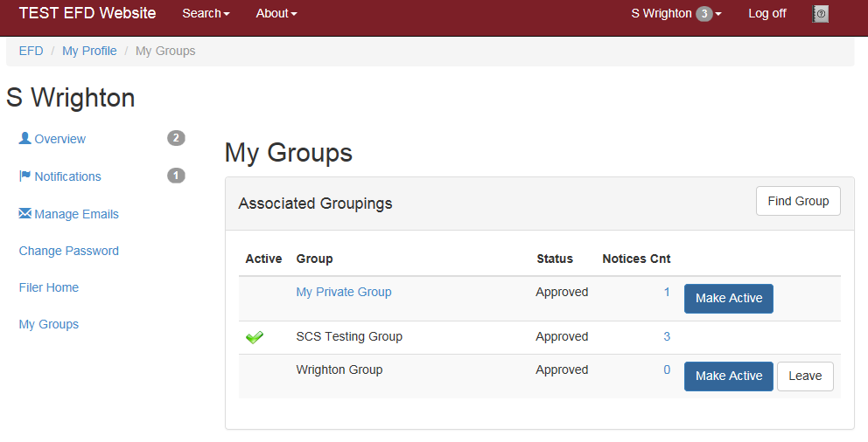
Figure 37 My Groups Screen
The My Groups screen provides access to five distinct functionality related to groups:
- Selecting the Make Active option allows the user to set the Active Group. Only a single group can be active at any given time.
- The Leave action allows the user to request being removed from the associated Group. Filers cannot leave a group which is their current Active group, Filers cannot leave a group for which they are the Group Super Administrator, and Filers cannot leave their Private Group.
- The Notice Count link sends the Filer to a screen which allows them to shift notices between groups.
- The Group Name link sends the Filer to the Group Details page.
- The Find Group Link allows the Filer to search for a group to request membership in.

Group Search
To locate the Group Search page, click the Find Group button on the My Groups page.
The Group Search screen allows the Filer to find groups which they may wish to join. Filers must search for a Group’s existence before they are able to create a new group.
To search for a Group, the Filer would enter at least 3 characters from the expected group name.
If a Group is marked such that they will not appear in Search Results, then they would not be found using this tool.
Private Groups are never returned in the Group Search tool.
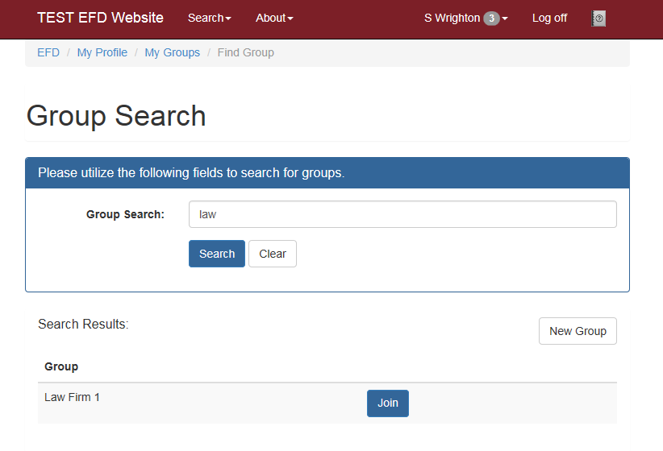
Figure 38 Group Search

Group Editor
To locate the Group Editor page, click the name of the group to edit on the My Groups page.
The Group Editor screen allows for the modification of the details of a group as well as the creation of new groups. Figure 39 shows an example of the Group Editor screen.
The Distribution Email is designed to allow for notifications about the status of the Group’s Notices to be sent out. These distributions include actions such as Regulator making a notice Deficient or upcoming notice expirations.
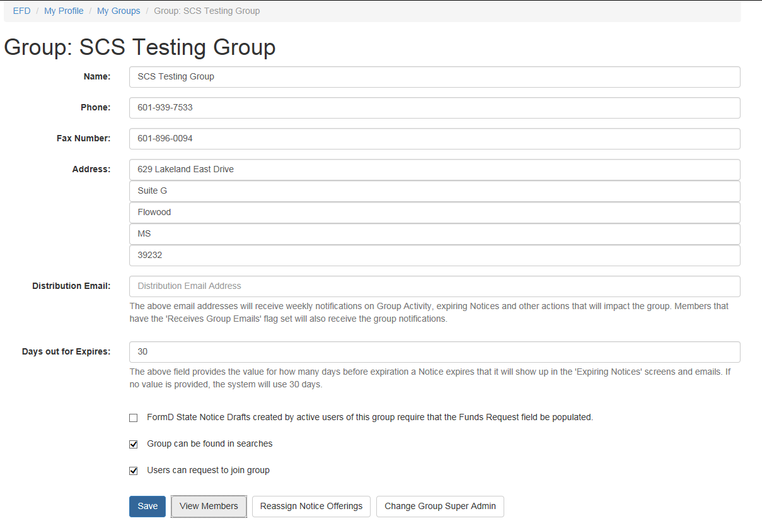
Figure 39 Group Editor Screenshot

Members List
To locate the Members List page, click the View Members button on the Group Editor page.
The Members List screen is the gateway for membership management of the group. This allows for Filers to be denied access to the group, as well as allowing membership approval.
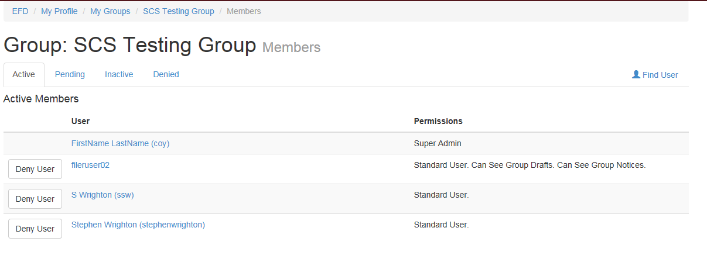
Figure 40 Group Members List Screenshot

Membership Editor

To access the Membership Editor, click the user to be edited on the Members List screen.
The Membership Editor screen allows for modifying the permissions that a Member has in regards to groups. Figure 41 displays an example screenshot of the Membership Editor.
Please note the Can Pay for Drafts flag. This flag allows users the ability to pay for the drafts they create for a group.
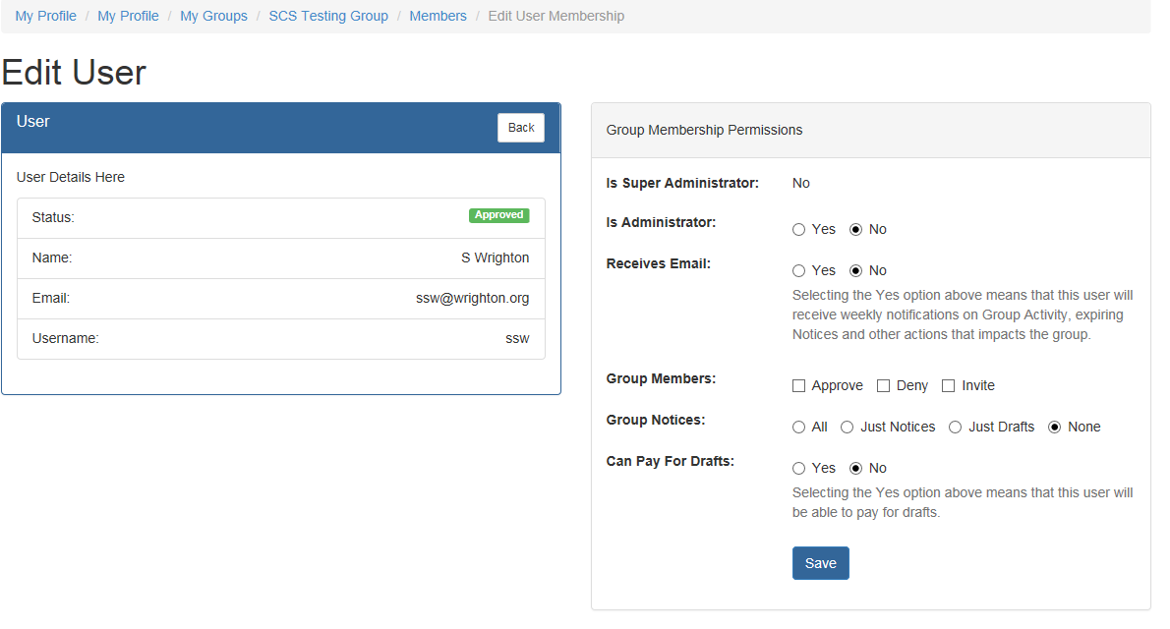
Figure 41 Membership Editor Screenshot

