EFD Filer Form D Notices
Navigate to the website https://www.efdnasaa.org to begin.

Purpose:
This document will show how a Filer can create new notices within the EFD system.

Background:
This document assumes that you have already registered with the EFD system. For help with EFD registration, please see additional help documentation for Registration.
Contents:
Purpose: 1
Background: 1
Screen: Home Page 2
Screen: Login Screen 3
Screen: Accept Terms and Conditions 4
Screen: Home Screen Logged In 5
Screen: Search Screen 6
Screen: Search Results 7
Screen: View Filing 8
Screen: Add Notice 9
Screen: New Notice State Selection 10
Screen: Sales Report Entry 12
Screen: Classes of Securities 13
Screen: Filer Information 14
Screen: Issuer Information 15
Screen: New Notice Confirm Details 16
Screen: ACH Payment Collection 17
Screen: View Receipts 18
Screen: Receipts Center 19
Screen: Active Notices 20
Screen: Filer Receipts 22
Questions: 23

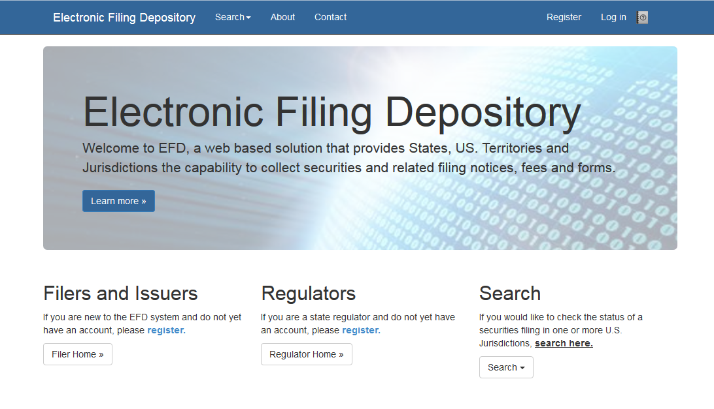
Screen: Home Page

This is the home page for the Electronic Filing Depository, which is available at https://www.efdnasaa.org.
Filers must complete the registration process to create a new account if they do not already have an account at EFD.
If a Filer already has an account with EFD, then the Filer clicks Log In at the top of the screen.

Screen: Login Screen
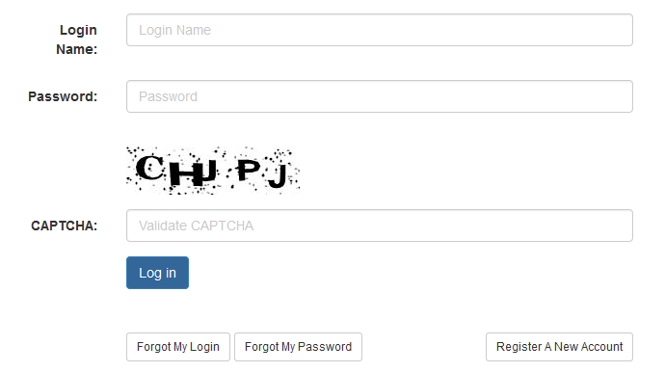

The Filer must enter their Login Name and Password and enter the CAPTCHA text where required.
The Login Name IS NOT case sensitive.
The Password IS case sensitive.
The CAPTCHA IS NOT case sensitive.

Use the option buttons at the bottom of this form to retrieve lost Login Names or Passwords.

Screen: Accept Terms and Conditions
Filers must click the Accept the Terms and Conditions button upon logging into the EFD website.
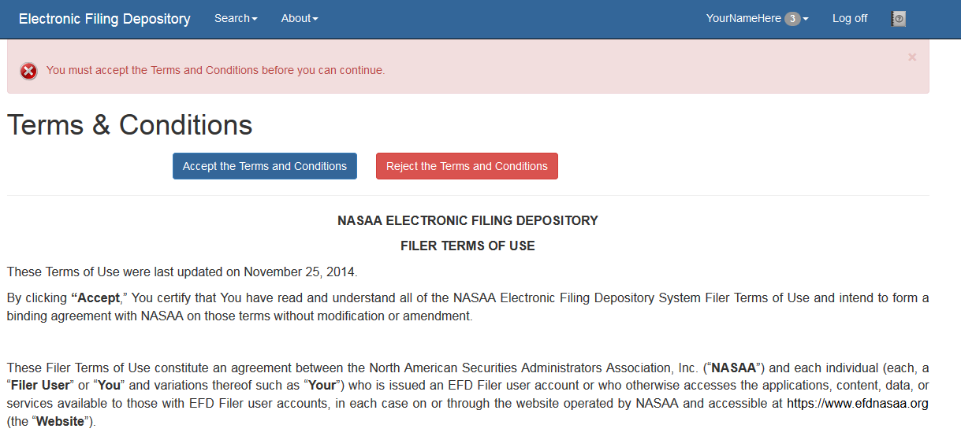

Filers will not be allowed to proceed until the Terms and Conditions on this screen are accepted.

Screen: Home Screen Logged In
After accepting the Terms and Conditions, Filers are logged in and the Filer’s Login Name will appear at the top of the screen.
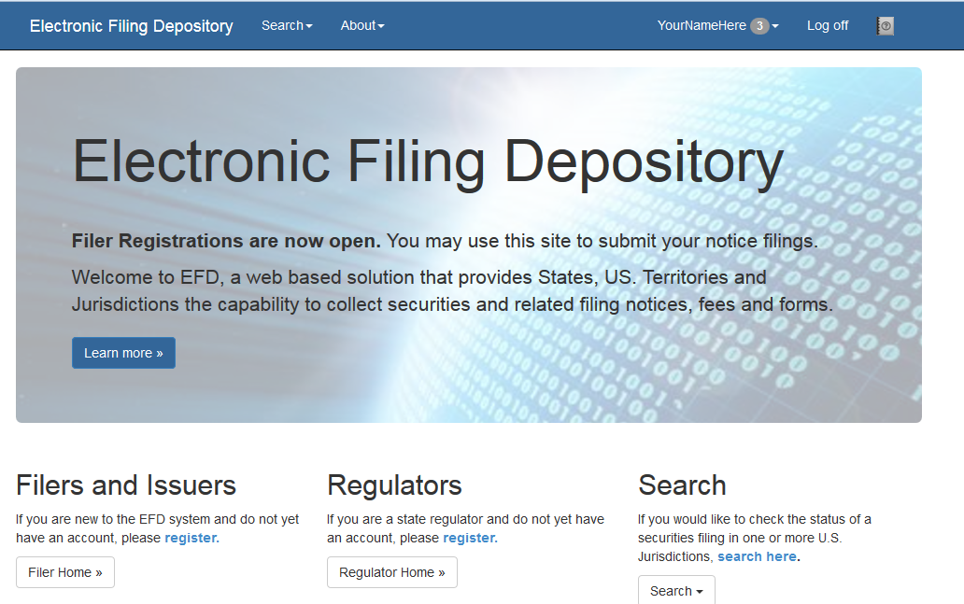

Filers may now begin the notice creation process.
Click Search and select Form D.
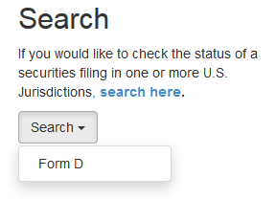

Screen: Search Screen
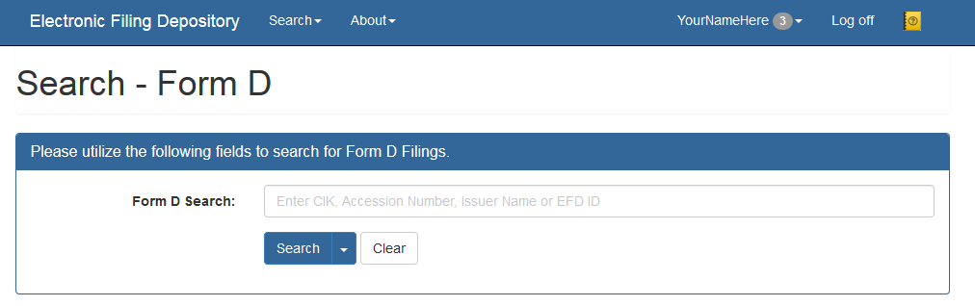

The Form D Search utility is used to search for the Form D Filing. Filers may use a variety of search criteria in the search input box including:
- Issuer CIK Number (Central Index Key)
- Issuer Name
- Accession Number
- EFD ID - Each Form D offering is assigned a unique EFD ID by the system that will follow the offering throughout its lifespan including amendments, renewals, terminations and withdrawals. The EFD ID ties associated accession numbers together and differentiates between offerings and offering series.
Filers may also use the drop down on the Search button to define what they are searching for. Filers may select from the following search criteria options:
- CRD Number
- Recipient Name
- Related Persons
- State File Number
- Signatures (as reported on the EDGAR Form D)
The search results are limited to show only the first 100 results. If more than 100 results are found, the total number of matching results is provided above the results list and can be accessed by navigating to the next page of results.

Screen: Search Results
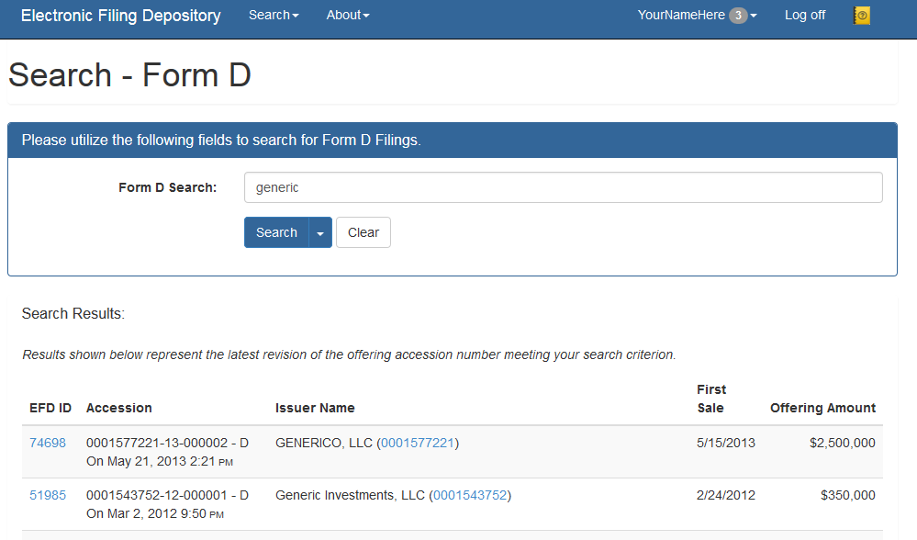
By clicking Search, Filers are provided with their search results. Click the EFD ID link to view the data retrieved from EDGAR.

Screen: View Filing
Clicking the EFD ID brings the Filer to the View Filing screen. The View Filing screen displays information that was downloaded from EDGAR by EFD. This data is stored within EFD and includes the actual Form D HTML page. 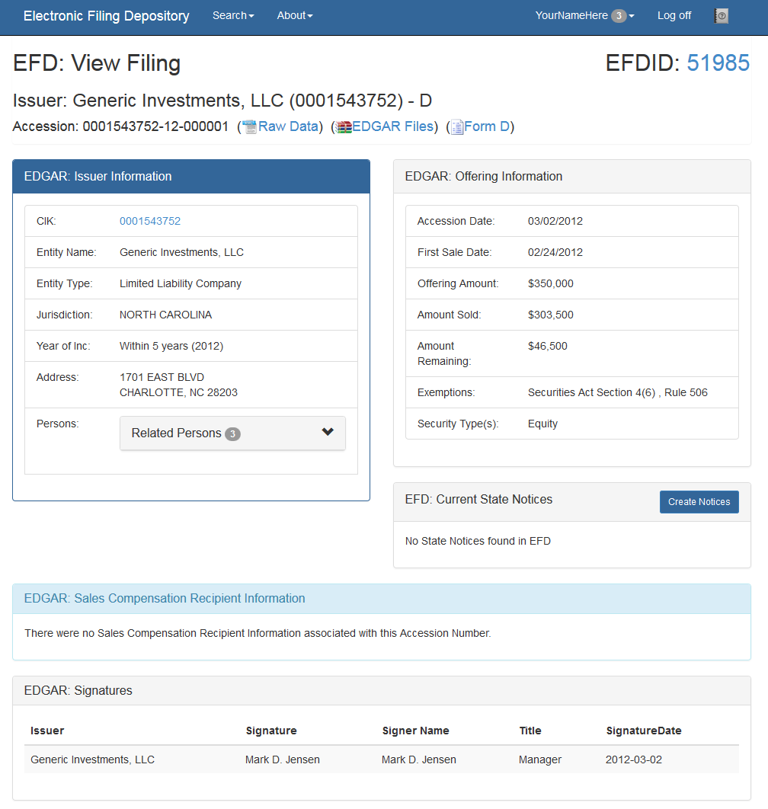
Once the Filer identifies the correct offering, click the Create Notices button.
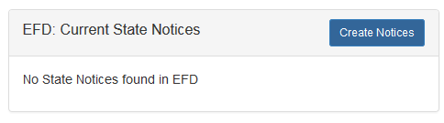

Screen: Add Notice

Clicking the Create Notices button directs the Filer to the Add Notice screen. The Filer must select which type of notice to be filed. For this example, the Filer selects a New Notice.

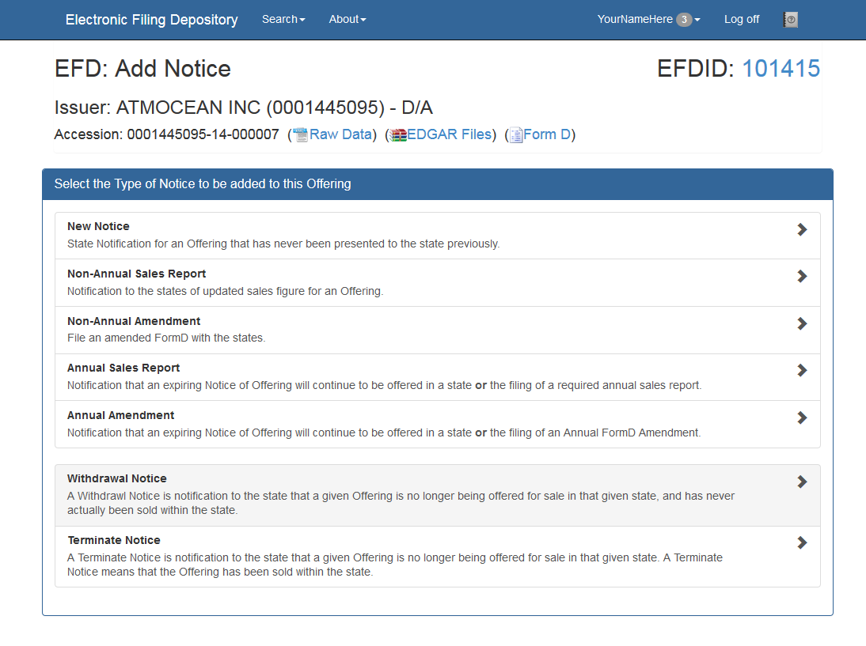

Screen: New Notice State Selection
Next, the Filer will use the checkboxes in the State Selection screen to indicate which U.S. jurisdictions they are filing in. In this example, the Filer selected District of Columbia.
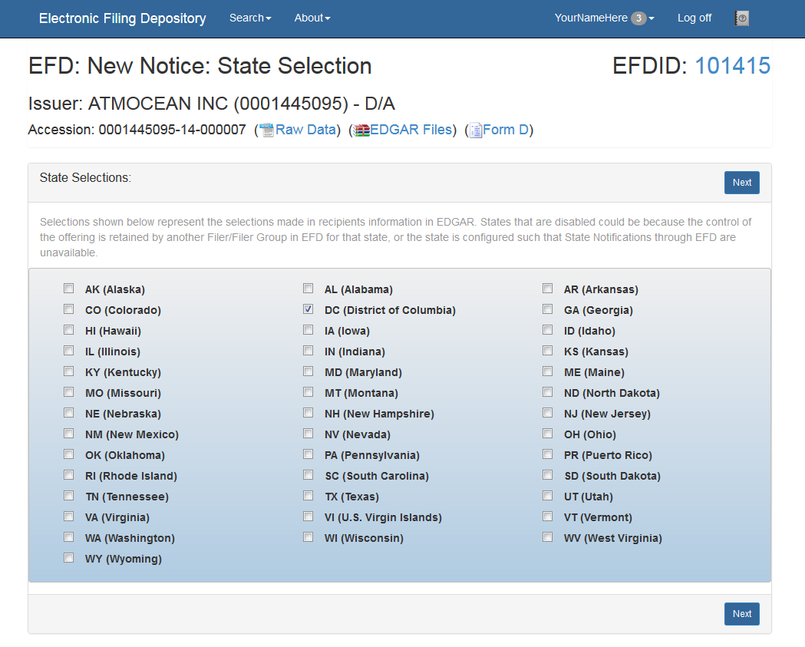

Click Next to proceed to the next step.

Screen: New Notice- Service of Process
Filers must accept and agree with the Consent to Service of Process before continuing to the next step.
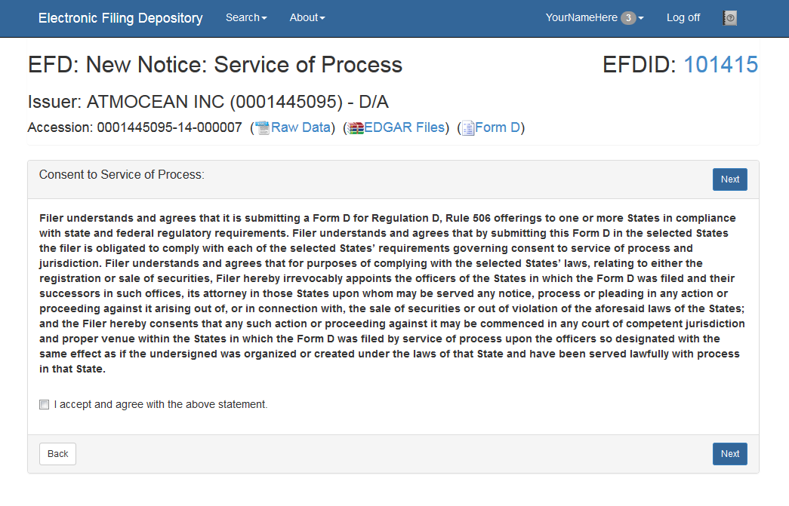
Check the box indicating that you accept and agree with the above statement and then click Next.

Please note that not every jurisdiction requires this consent. Filers will only be required to consent to service of process if required by the jurisdiction(s) they are filing in.

Screen: Sales Report Entry
The sales report screen allows Filers an opportunity to enter sales report information specific to the jurisdictions they are filing in. If the Filer selected more than one U.S. jurisdiction they will see more than one U.S. jurisdiction listed below. Each row of input boxes is designed to collect sales report information specific to the respective U.S. jurisdiction.
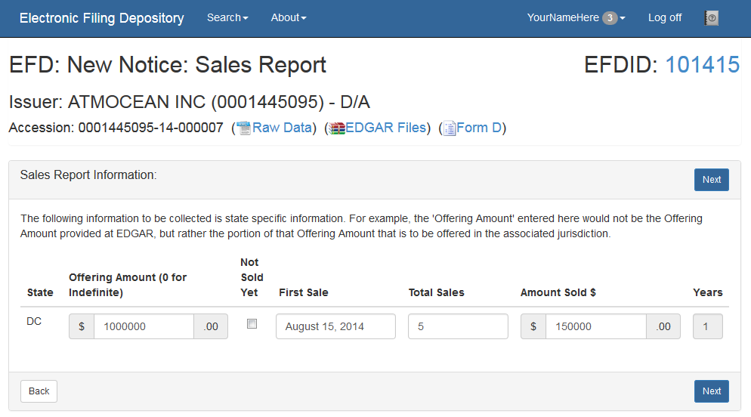
Each U.S. jurisdiciton may have different input requirements for Sales Reports.
- Red outline - Input is REQUIRED
- Grey outline - Input is OPTIONAL
- Disabled - Input is not available
Offering Amount - The amount of the offering being offered within that U.S. jurisdiction. Enter “0” if the offering is “Indefinite.” If “0” is entered, then the Maximum state fee will be assessed during checkout.
Not Sold Yet – Check this box if no sales have been made IN THIS U.S. JURISDICTION. The remaining fields will be disabled for input if the “Not Sold Yet” box is checked.
First Sale – Enter the date of the first sale IN THIS U.S. JURISDICITON.
Total Sales – Enter the total number of sales within THIS U.S. JURISDICTION to accredited and non-accredited investors. This is the count of the sales within the state.
Amount Sold $ - Enter the total amount sold IN THIS U.S. JURISDICTION.
Click Next to continue.

Screen: Classes of Securities
The Additional Data Entry screen provides Filers the ability to declare the classes of securities being sold. Not every U.S. jurisdiction requires this information to be collected, but for those states that do require this information, EFD will automatically prompt Filers to enter Classes of Securities with the following screen:
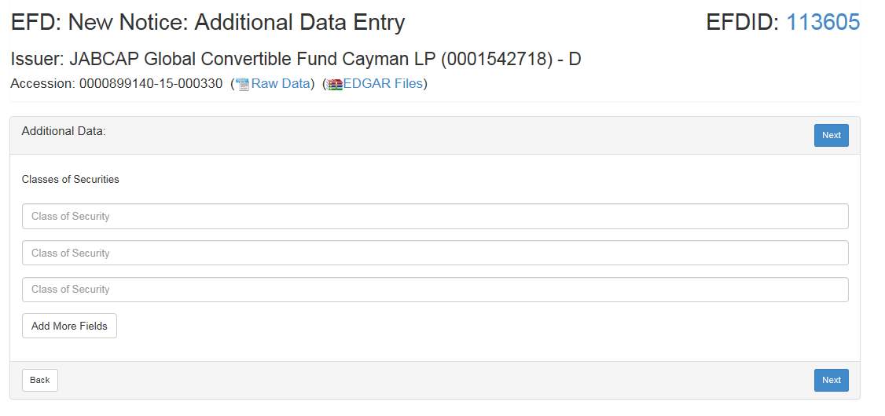
Click Next to continue.

Screen: Filer Information
The Filer Information screen collects information from the Filer to ensure a proper and secure filing payment process.
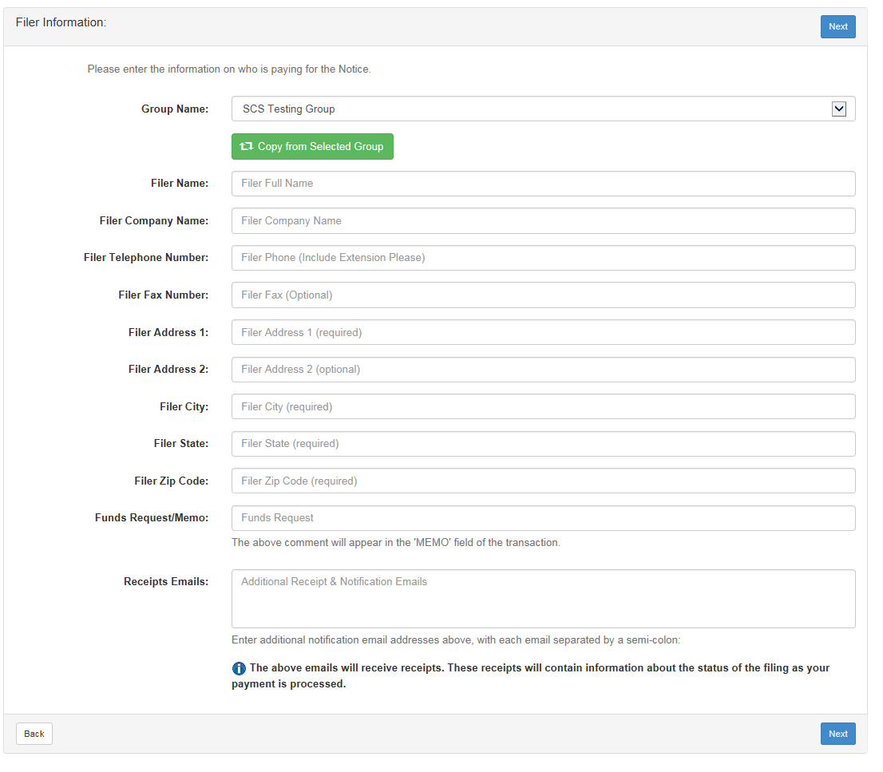
Use the Copy from Selected Group button to automatically copy this information from the Filer’s group profile. Filers may also manually enter their information.
Please note that Receipts Emails are used as a way for additional people to be notified by EFD via email about the filing of these notices. These additional email addresses will also be sent information when a notice is expiring. This information is only visible to the Filer, the Filer group administrators and the regulators within the states the Filer is filing in.
Click Next to continue.

Screen: Issuer Information

The Issuer Information screen collects information related to the Issuer.
Much of the information requested on this screen already exists on the EDGAR Form D filing. Use the Copy from Offering button to automatically copy the information into these fields. Filers may also input this information manually.

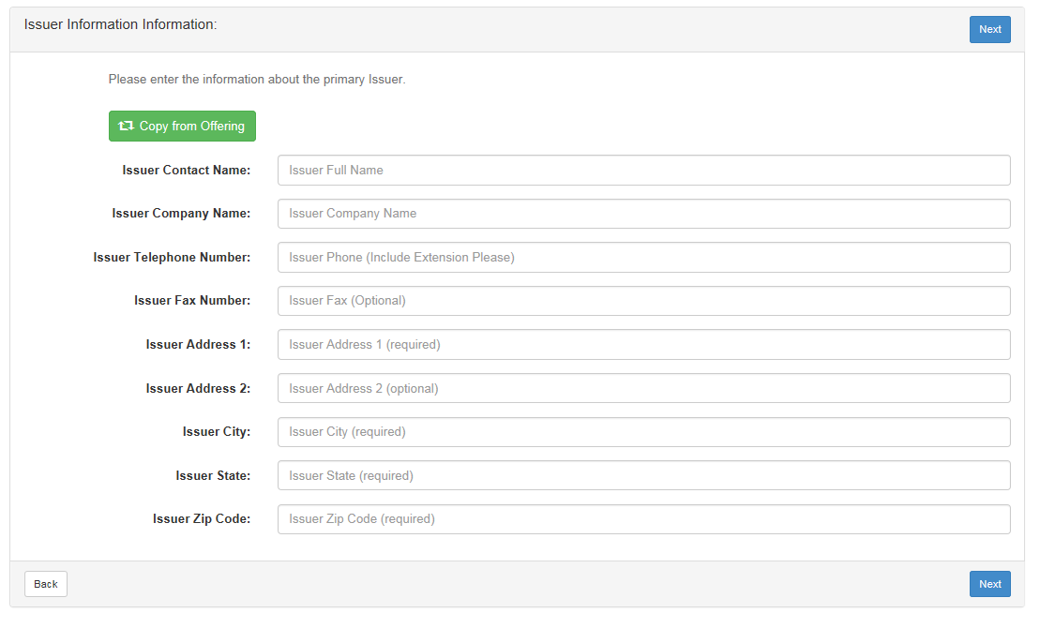
Click Next to continue.

Screen: New Notice Confirm Details
The Confirm Details screen is provided as a way for Filers to confirm their input entries and to review the fees being assessed by the EFD system. If applicable, late fees will also be included on this screen.
The Standard EFD System Use Fee is assessed one time in the lifetime of each offering.
At this point, Filers may choose to perform the following actions:
- Print – Print for your records
- My Drafts – Jump to the Filer’s Drafts page.
- Pay Now – Use this form to submit an ACH payment. Please note that EFD currently only accepts ACH payments.
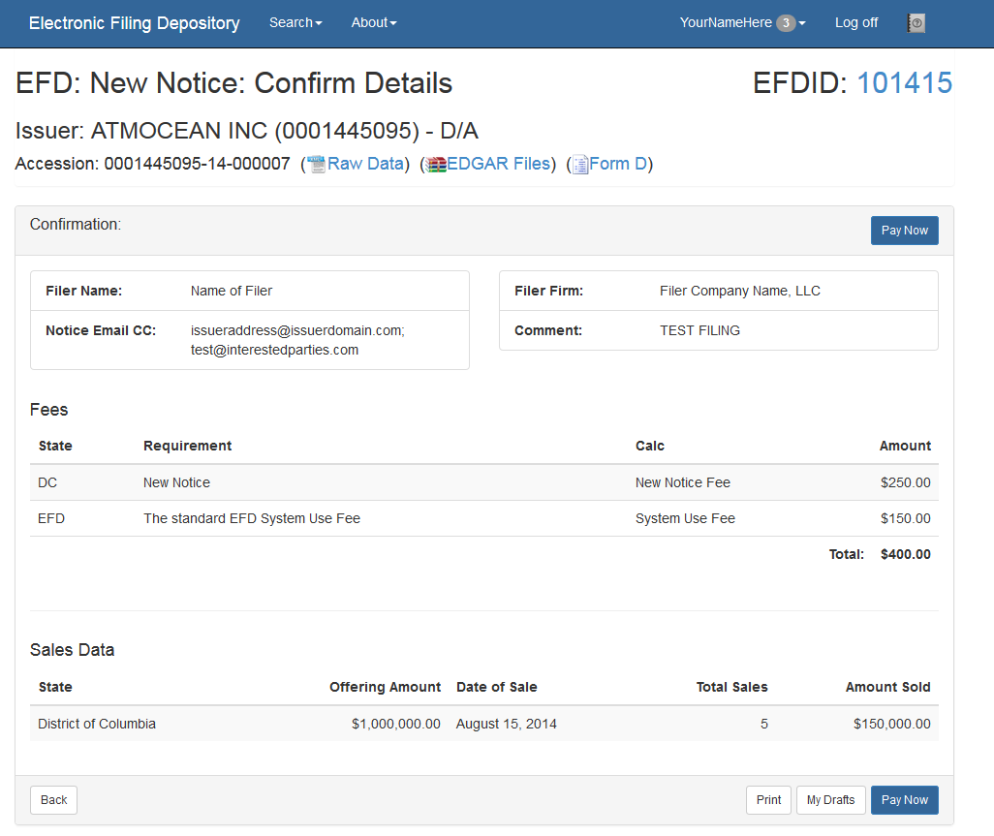
Click Pay Now to finalize the notices.

Screen: ACH Payment Collection
The following screen collects ACH payment information. Enter the Routing Number and Account Number. Please note that EFD will not save this information, and that Filers will be required to enter this information each time they wish to submit a payment.
Click the box to accept the payment terms and then click Make Payment.
Filers will be notified via email if there is a problem with the payment. New Filings, Amendments and Renewal Filing Notices are considered FILED and publicly visible as ACTIVE the moment an ACH payment is initiated. If a problem arises with your payment, such as Non-sufficient Funds (“NSF”) or a Bad Account Number, then the filings will be marked as DEFICIENT FUNDS and become publicly visible as INACTIVE.
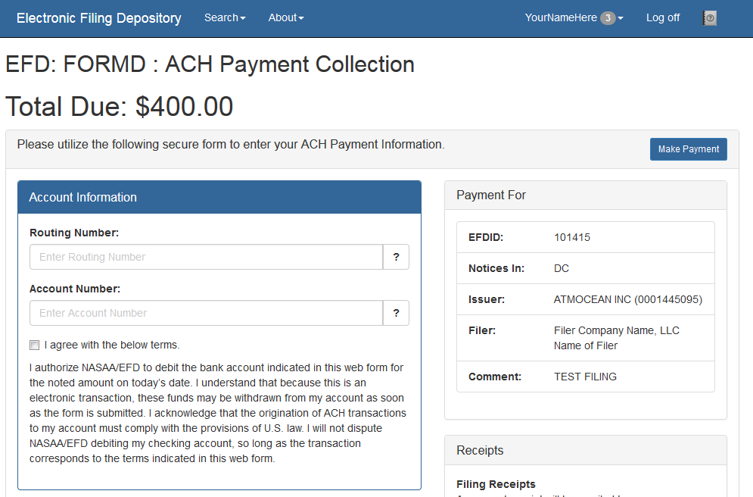

This site is a secure transaction over SSL and your sensitive data is saved in the EFD system only long enough to complete this one time ACH transaction, complying with Federal PCI regulations.

Screen: View Receipts
The following screen shows a payment receipt once the Filer has initiated a payment within EFD. Note that there is a Print button at the top of the page so the Filer may print a printer friendly version of this page.
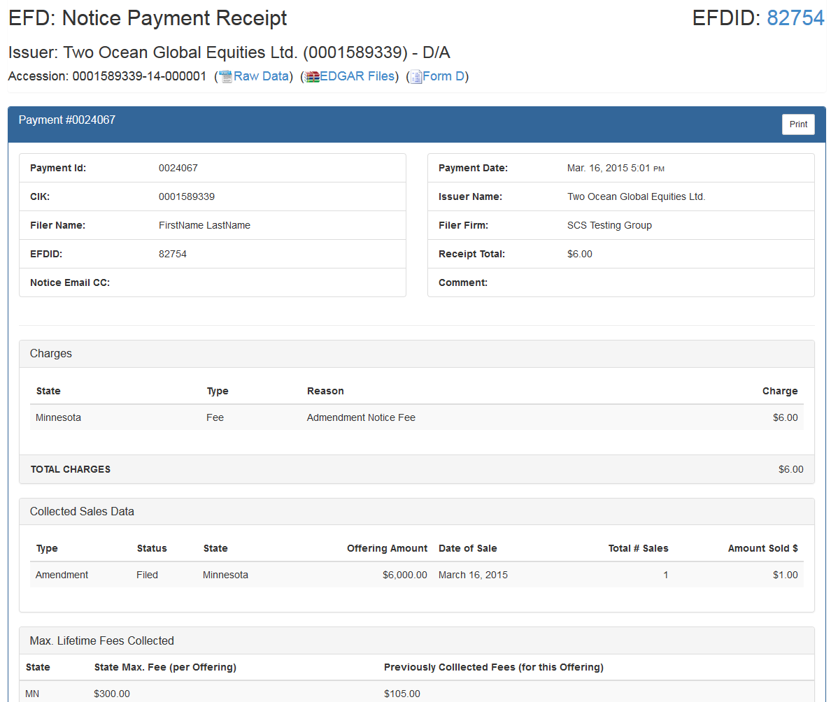

Screen: Receipts Center
Filers can access their receipts at any time by clicking the Receipts Center link from the Filer Home menu.
Use the radio option buttons at the top of the screen to view receipts from different levels of your group when applicable.
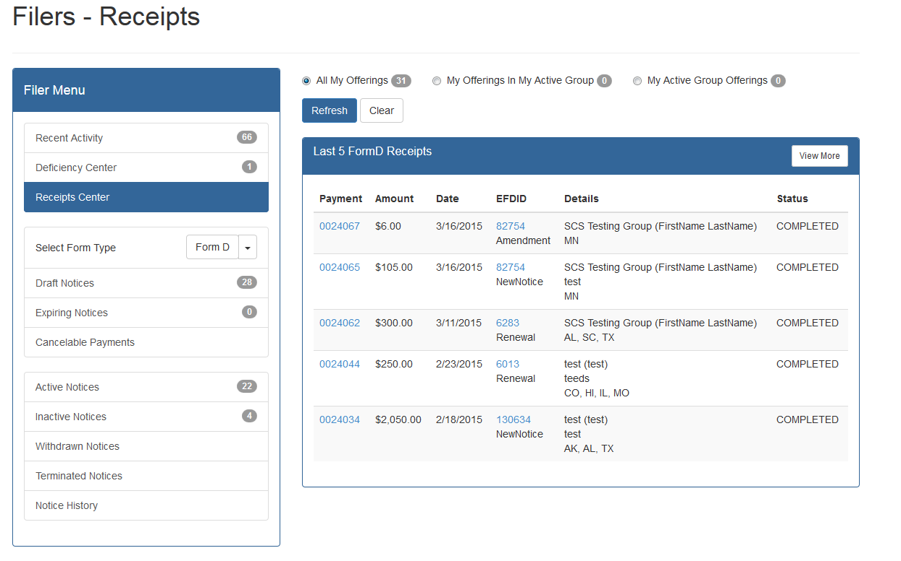

Screen: Active Notices
The following screen is accessed by clicking Active Notices in the File Home menu. This screen displays notice filings organized by issuer. The issuers are sorted by Issuer Name.
- NOTE THE FOLLOWING FILINGS ARE TESTING VALUES AND DO NOT REPRESENT ACTUAL NOTICE FILINGS. THESE SCREENS ARE FOR DEMONSTRATION PURPOSES ONLY
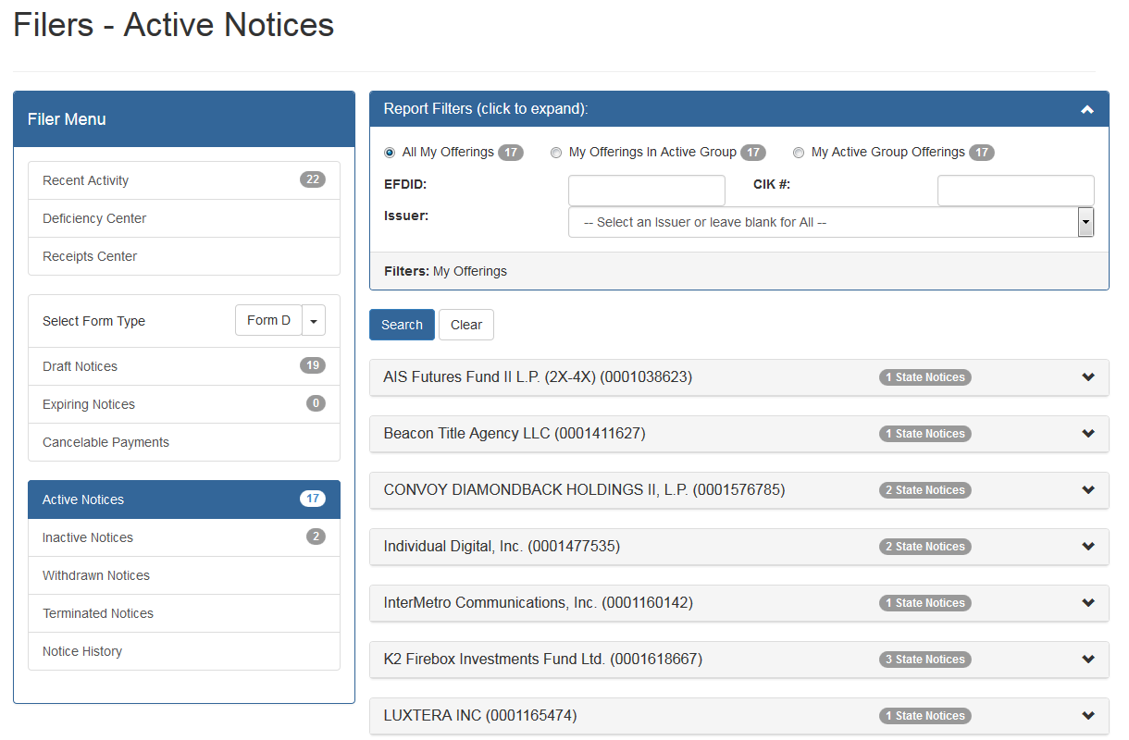
Click the pull down to see the notices associated with a particular issuer.
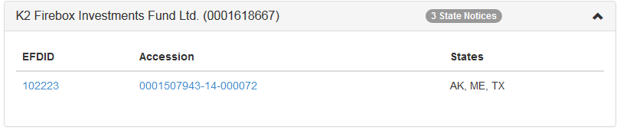
Click the Accession number to see the details about each of the notices sent for this offering:
- NOTE THE FOLLOWING FILINGS ARE TESTING VALUES AND DO NOT REPRESENT ACTUAL NOTICE FILINGS. THESE SCREENS ARE FOR DEMONSTRATION PURPOSES ONLY
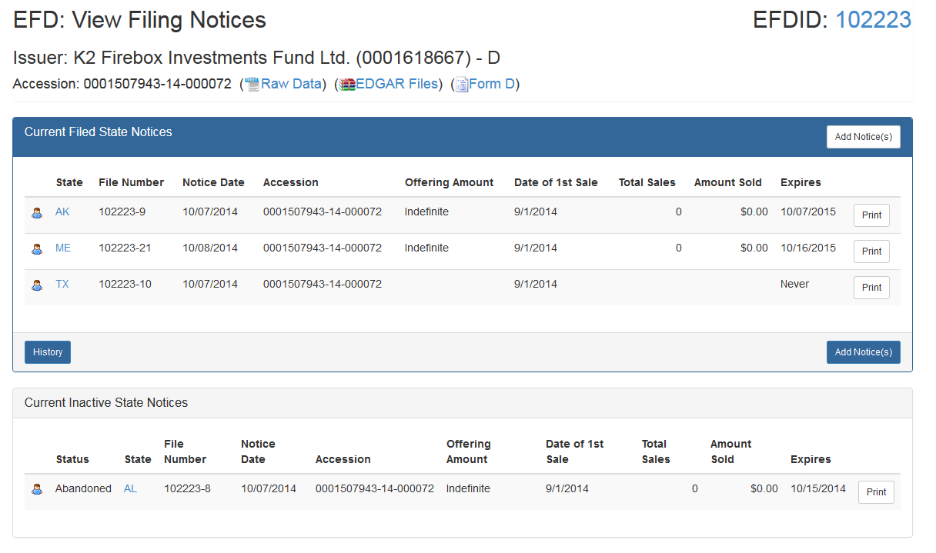

Above you will see that there are 3 ACTIVE notices and 1 INACTIVE Notice. The INACTIVE notice is an abandoned notice.
- NOTE THESE FILINGS ARE TESTING VALUES AND DO NOT REPRESENT ACTUAL NOTICE FILINGS. THESE SCREENS ARE FOR DEMONSTRATION PURPOSES ONLY

Screen: Filer Receipts
The following screen is accessed by clicking the Receipts Center link from the Filer Menu.
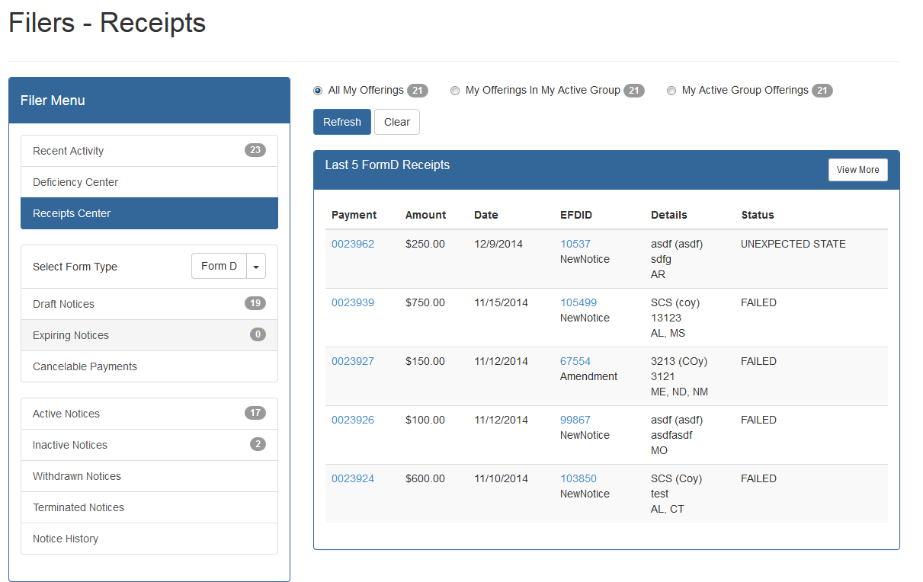

Payment ID: this is a Payment Transaction ID for your records or when contacting EFD support.
Amount: this is the total amount of the ACH transaction. This may include more than one state or jurisdiction or the System Use Fee.
Date: this is the date the payment transaction was submitted to EFD. This also serves as the notice filing date.
EFDID: this is a unique ID of the offering. This ID will be used throughout the life of the offering including subsequent EDGAR accession numbers and amendments.
Status: This identifies the Status of the payment. If a failure has occurred due to NSF or bad account information, a notice via email and any notices associated with this payment will be marked as DEFICIENT – FUNDS and placed in the INACTIVE filings for the offering. The filings will also be placed into the Deficiency Center, accessible by clicking Deficiency Center from the Filer Home.

Questions:

NASAA EFD Support
601-453-1979
support@efdnasaa.org
Support Hours
8/9 am EST – 5/6 pm EST
Excluding National Holidays

